CIPFA North West Society



**Presidents Blog – April 2015**

I became President on 26 March this year at the AGM held at the Halliwell Jones stadium in Warrington. I understand that the President chooses the venue for the AGM relative to their work or home location. So rather than ask everyone to come over to where I live in North Wales, the work location it was. Warrington is a (very) big rugby town and I am a little ashamed to say that it wasn’t until I’d been working there for two years that I actually attended a match. I finally redeemed myself though.

We were given a tour of the stadium after the AGM which included a visit to the changing rooms and a look in the ice bath that had been used that day. Delightful! Unfortunately the stadium manager wasn’t that experienced in taking photos – hence the presence of his thumb on this photo!

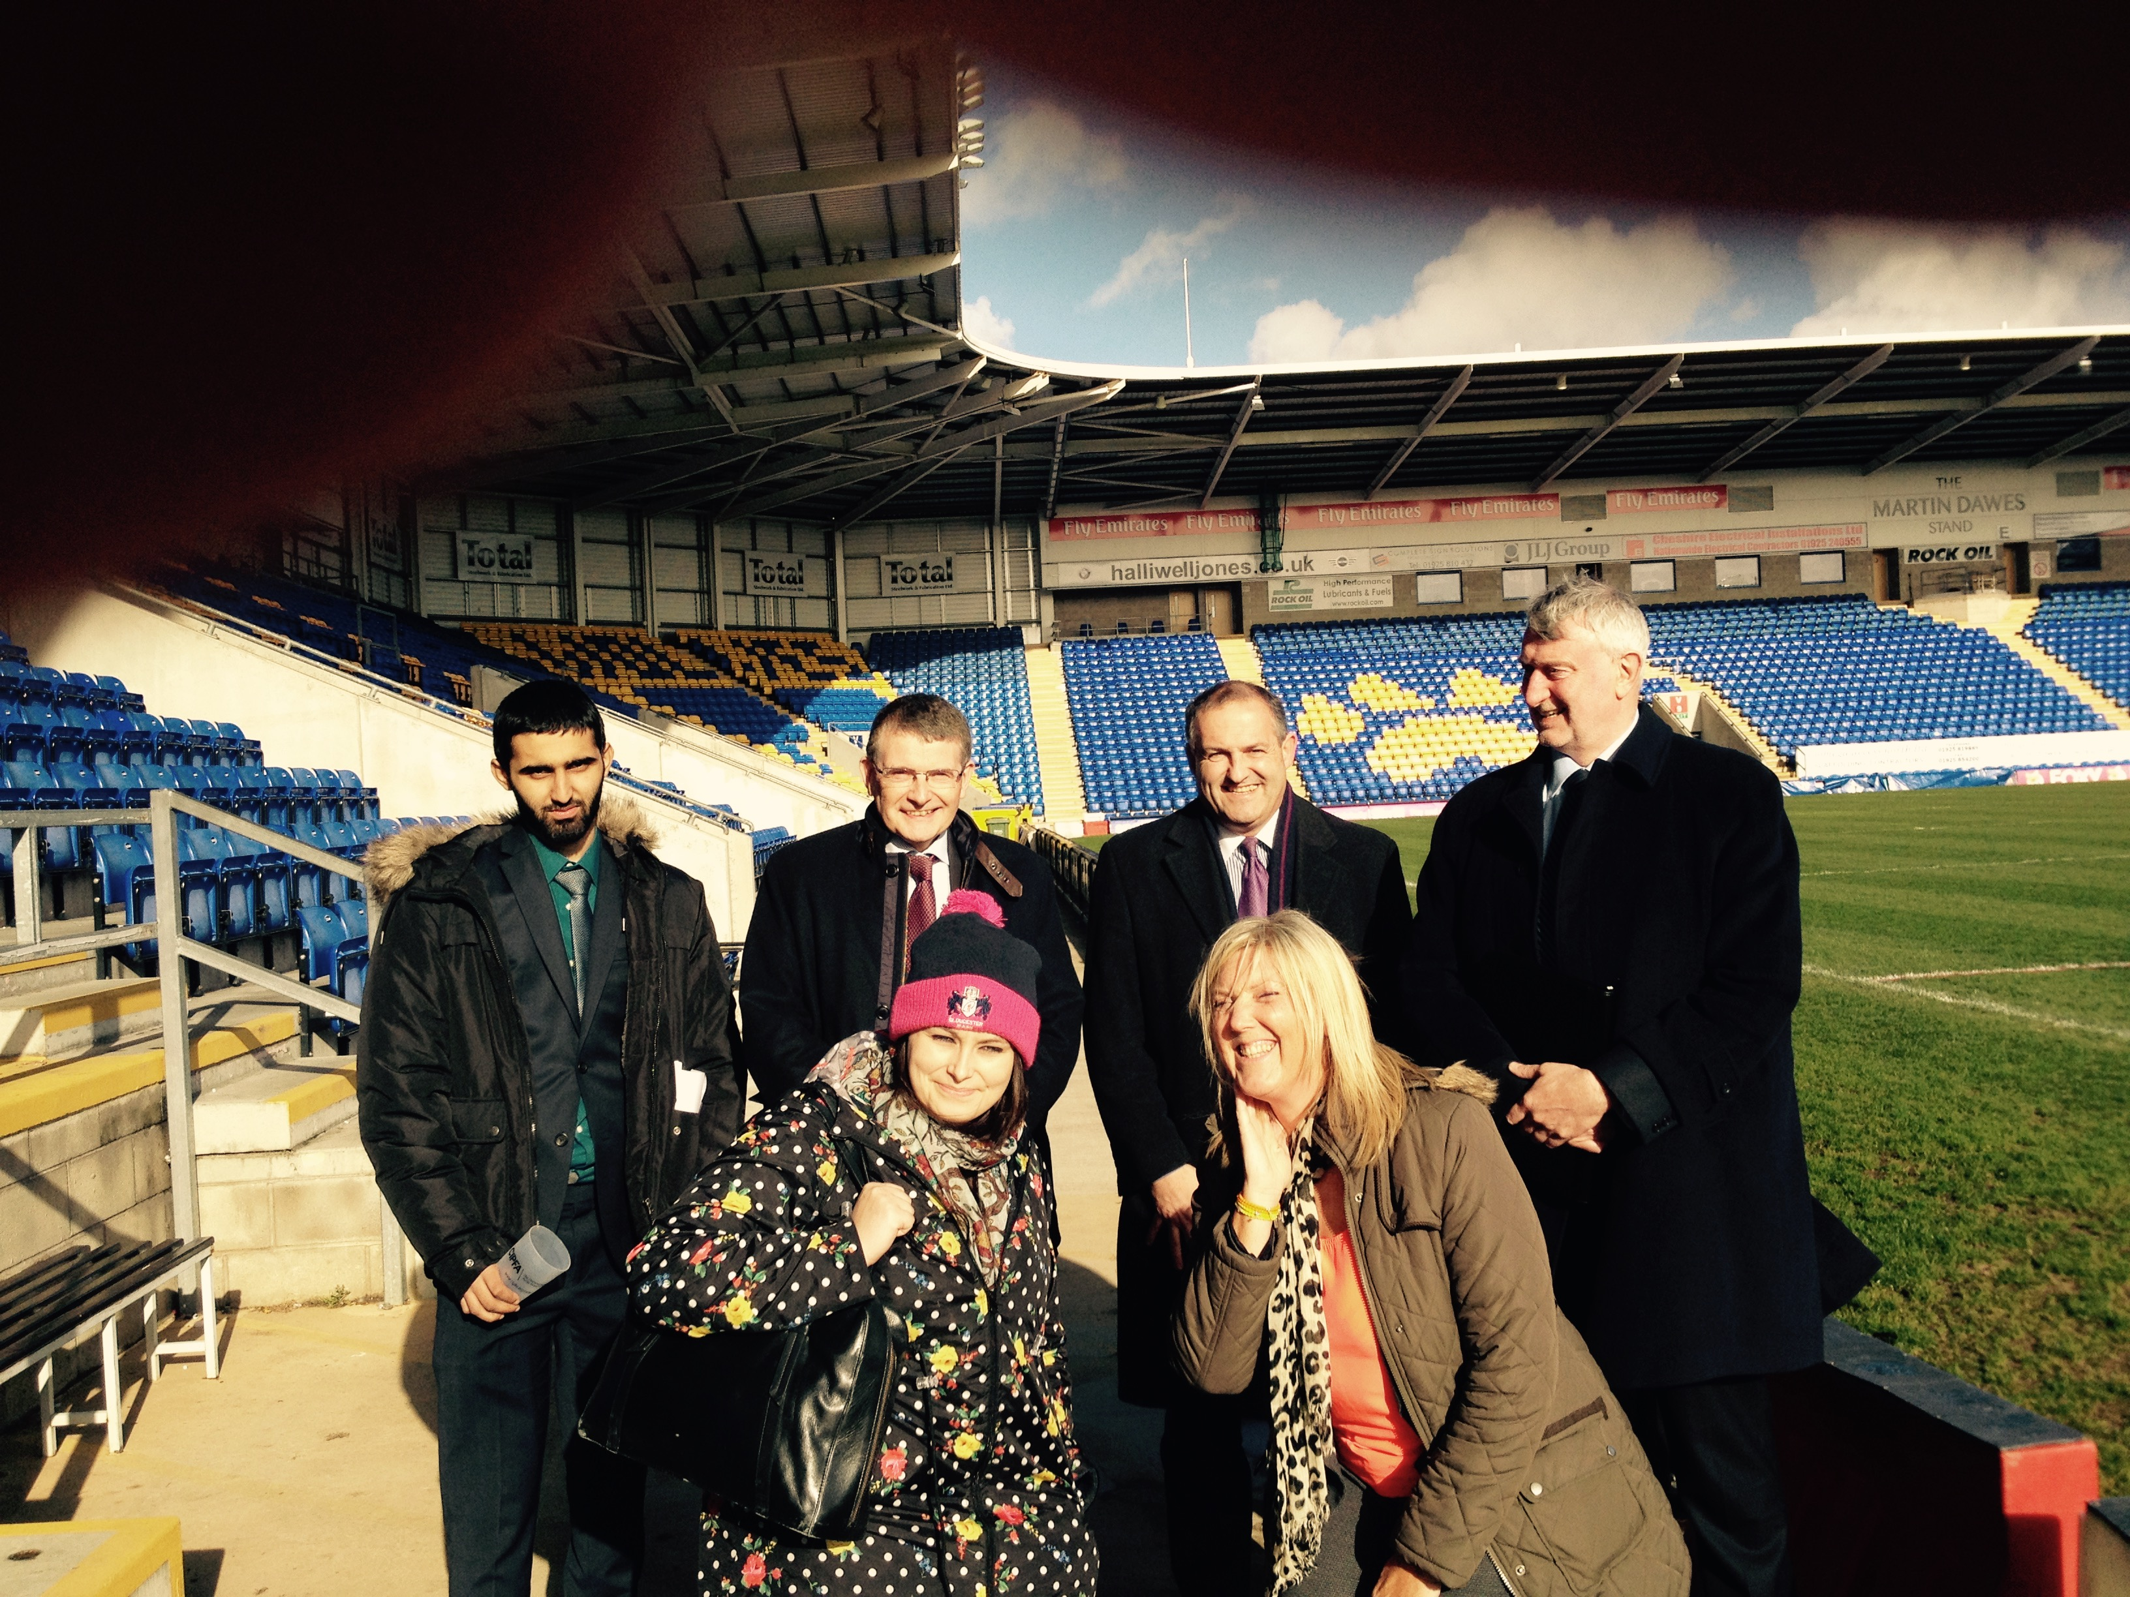



We had our first Council meeting of the financial year on 17 April (in Warrington…..) and welcomed new Council member Liga Berzina, President of the North West CIPFA Student Network (CSN) and Vice Chair of the Audit, Risk and Governance Group, Jean Gleave.

We also have a new Society Treasurer following the departure of David Hodgkinson down to the ‘big smoke’ to a new job in Westminster Council. We wish Dave all the best in his new position and with his relocation and thank him for the time he spent as Treasurer and on the Society Council. Our new Treasurer is Jonathan Davies from Oldham Council and we will formally welcome him at the next Council meeting in July.

The Society Council provides the governance and link between the regional membership and the CIPFA Institute, helping drive national initiatives locally, supporting regional members and raising the profile of the Institute throughout the region.

We had a lot to discuss as the Institute has been very busy over the past month, having recently closed the consultation on its Governance review. The proposed new structure will see national Council Members elected on a regional basis rather than on a sector basis as they are now. So we needed to consider how we wold support this proposal and if there was any immediate impact for us. The proposal will go to the national AGM for approval on 7 July but won't take effect until 2017.

On my wish list this year is to re-establish the Retired Members Group as we had some great engagement from the retired members a few years back when the group was going. Liga had a great idea that retired members could mentor students and support them in their studies and with the transition from student to full Member. I am tasked with talking to some of our retired members to see what they think so watch this space. If you are a retired member and think this is a good idea and want to get involved, let me know and can have a chat about it.

I have been busy this month updating our social media sites. In February I attended a seminar at an AAT workshop, where I was on the CIPFA stand, hosted by Aimee Bateman of Careercake.com. Aimee opened my eyes as to the value of social media and I vowed to be more active in updating our sites. I must admit that I’ve not been as active as I’d like as I’ve had to fit it in among other commitments, but I’m getting there. Our Council members will also post information about the North West sub groups as well so hopefully the sites will be really active again. We have 3 social media sites:

* **Twitter –** search [twitter.com/CIPFANW](https://twitter.com/CIPFANW)
* **LinkedIn –** search for the Group CIPFA North West
* **Facebook –** search for the Group CIPFA North West

Some of the North West sub groups have their own pages too. Take a look and see what you think, we’re always happy to receive feedback

Planning is underway already for our flagship event – the Regional Conference and Annual Dinner which is being held on Friday 13 November 2015. I don’t yet have a venue but we are looking at places and we might well hold it in Manchester or perhaps go back to Preston where it was held last year. It was a great venue although a lorry fire resulted in much traffic and some delegates and dinner guests were held up as a result. We have some speakers earmarked and have ideas about others. By the next Council meeting in July we hope to agree a venue and will have something more tangible to post on the website for people to book in early if they wish

Finally some very sad news. I heard at the AGM that former Institute President and North West Chair, Bill Jolliffe had passed away. When I met Bill he was a very active retired member and I used to look forward to seeing him and his wife, Audrey, dancing the jive at the annual dinners – even though he was in his 80’s! There will be a lovely obituary in the next edition of Spreadsheet magazine. As a result of his tremendous past service to the Institute both nationally and regionally I am going to rename our Volunteer of the Year award after him to The Bill Jolliffe award. That way his legacy will continue and I hope stories will be told of his time at CIPFA each year the award is presented at the annual dinner.

Well that’s all from me for April 2015. I hope you found this blog interesting as it’s a new thing for the region but I hope it gave you an insight into some of the things we do and aim to do to support you as Members and Students. Outside of CIPFA, following my success on the Grand National (£10) I will be looking forward to attending Chester Races in May where I hope I will be able to continue my winning streak. Let see eh…..

Shaer