Contents
PAGE
Contents 2
Using the Self-Evaluation Framework 3
A. Self-Evaluation: Supported Person Participation 7
B. Self-Evaluation: Management Responsibilities 16
C. Self-Evaluation: Financial Management Risks 27
D. Self-Evaluation: Summary 37

Using the Self-Evaluation Framework

- The self-evaluation framework provided is intended to help authorities to identify the financial implications of SDS implementation, in order to assist in establishing appropriate financial management planning and arrangements which help support Self Directed Support outcomes.

- The framework is based on self-evaluation of the following three key aspects of SDS management:

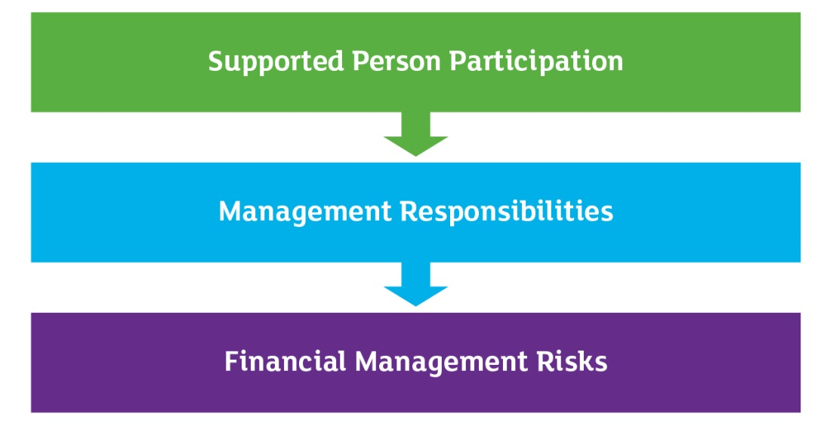

- Each of these aspects is considered by a separate evaluation grid. Each evaluation grid is structured in a consistent way to reflect the different roles identified in the guidance that accompanies this self-evaluation framework. The roles are illustrated in the diagram below.

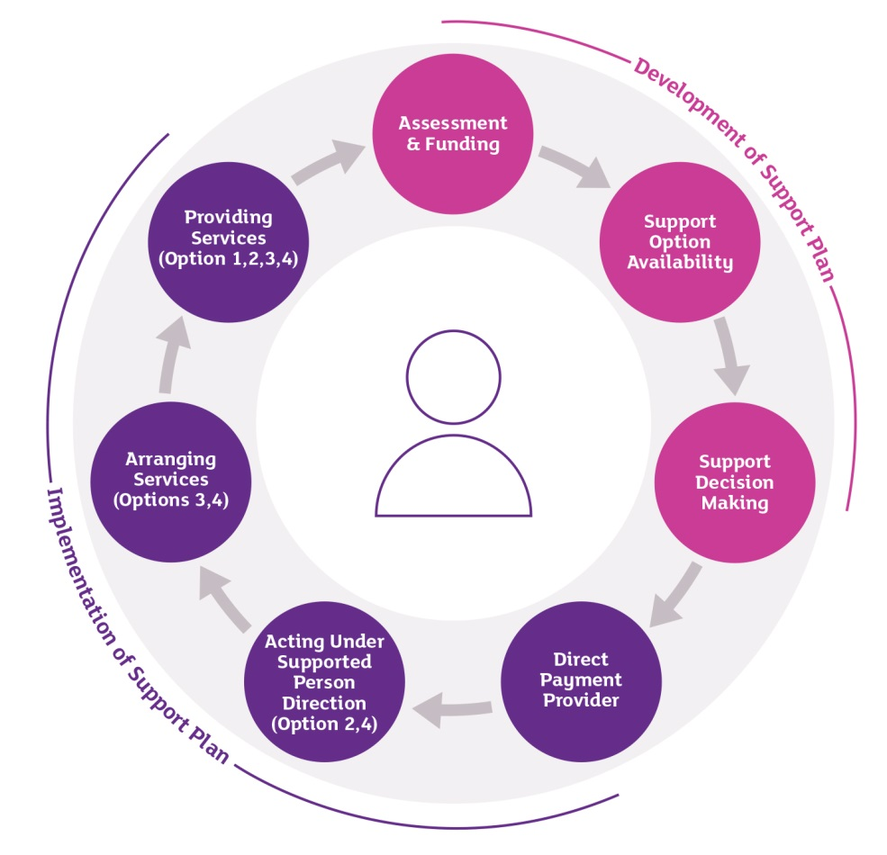

- The items and questions identified in the framework are not exhaustive or all inclusive. Therefore additional items, for example other unidentified risks, may be recognised and added while using the self-evaluation framework. This framework is provided as a word document to facilitate ease of use and flexibility for authorities.

- In using the self-evaluation framework please note:

  - It is recommended that an appropriate group of people involved in SDS undertakes the evaluation. Ideally this will include, as a minimum, relevant social care and finance staff, although other staff, such as procurement experts, will ideally be included.

  - Some authorities may also wish to involve service user representatives, third party service providers, advocacy groups, third party budget holders and other public bodies.

  - Each evaluation grid may be completed by the same person or group however some authorities may wish to ask different groups or people to complete each grid.

  - Relevant references are provided for each item in case of queries arising during the self-evaluation process

  - Before deciding upon the evaluation of a particular item the first question that should be asked is ‘What evidence do I/we have to base the evaluation on?’

  - A scoring summary sheet is provided after each grid to record the scores, compared against the maximum possible, for each aspect and role. A summary table is provided at the end of the framework to provide a clear overview.

  - Arriving at an evaluation score is not an end objective. Identification of what action is appropriate to support SDS outcomes achievement and the consequent resource implications is the key objective of the framework. A group approach will assist by allowing discussion of possible actions and relative priorities.

SCORING SYSTEM

- A scoring system of 1 to 5 is used for each item, with 1 being ‘poor’ and 5 being ‘excellent’. Evidence to support the score should be identified and recorded. In some cases an element of judgement will be necessary.

- Having considered the evidence for each item and assessed the current arrangements, the action that is considered appropriate and the key resource implications should be recorded. Clearly a low score for a specific item will indicate that action is necessary. In some cases no action may be required.

- As well as providing an item by item (line by line) indication of areas for attention, a review of the summary totals for each aspect and role, comparing the self-evaluation score against the maximum score, will assist in providing an overview of key areas for action to assist in prioritisation. This may be of particular assistance for senior management.

Self-Evaluation: Supported Person Participation

1. | Supported Person Participation in Achieving Outcomes
 | Item | Evidence/Comments | Score  [1-5] | Planned Action and  Resource Implications
1.A.1 | A person can self-refer for consideration of assessment [Statutory Guidance 5.1 pathway diagram, see also 7.1, 14.21 regarding reablement]
1.A.2 | The supported person collaborates and is involved in the assessment process, to the extent they desire  [Statutory Guidance 4.5,4.7]
1.A.3 | Needs and outcomes specific to the supported person are identified [Statutory Guidance Table 1]
1.A.4 | Information and advice regarding the assessment process, eligibility criteria and support options is provided to the supported person [Statutory Guidance Table 3, also 6.3 diagram 2]
- Evaluation of Participation in ‘Assessment and Funding’ |  |  |  | Maximum Score | 20
1.B.1 | The supported person has a meaningful choice in deciding on the support package within the resources available [Practitioner Guidance p20]
1.B.2 | There is a collaborative and partnership approach to identification of support options [Statutory Guidance 4.7]
1.B.3 | Alternative funding and other resources to maximise the width of options available for the supported person are identified [Statutory Guidance Table 10]
- Evaluation of Participation in ‘Support for Option Availability’ |  |  |  | Maximum Score | 15
1.C.1 | The supported person has access to impartial information and advice on alternative support options; including direct payments, third party providers and budget management [Statutory Guidance 6.2]
1.C.2 | The supported person is empowered and supported, including training, to make decisions [Statutory Guidance 7.21-7.22]
1.C.3 | The supported person receives clear advice on their appropriate and proportionate responsibility to demonstrate accountability for the use of public resources under each option [Statutory Guidance Table 1]
- Evaluation of Participation in ‘Support for Decision Making’ |  |  |  | Maximum Score | 15
1.D.1 | The supported person has management of their own financial and procurement arrangements in achieving outcomes [Statutory Guidance 8.3]
1.D.2 | The supported person is consulted regarding the financial monitoring arrangements, ensuring they are proportionate [Statutory Guidance 4.7]
1.D.3 | There is flexibility in the provision of a Direct Payment under the terms of a supported person agreement [Statutory Guidance 8.4; table 8]
1.D.4 | There is the potential to employ a Personal Assistant, with appropriate information and advice available [Statutory Guidance 8.4; table 8]
1.D.5 | There is timely notification of any contribution required to be made to the cost of the care package [Statutory Guidance 8.5]
1.D.6 | The supported person can request a ‘gross’ payment arrangement, subject to authority agreement, where a contribution is being made by the supported person [Statutory Guidance 8.6]
1.D.7 | There is flexibility in the use of the Direct Payment [Statutory Guidance 8.6]
1.D.8 | The supported person is responsible for financial management and monitoring of the direct payment and its use [Statutory Guidance 8.10]
- Evaluation of Participation in ‘Direct Payment Provision’ |  |  |  | Maximum Score | 40
1.E.1 | The supported person specifies the services preferred, in accordance with the agreed outcomes and within the limitations of procurement law [Practitioner Guidance p37]
1.E.2 | The supported person specifies the service provider preferred, within the limitations of procurement law [Practitioner Guidance p37]
1.E.3 | The supported person receives proportionate information on expenditure, outstanding commitments and the relevant amount remaining [Statutory Guidance 11.40, 11.43-11.44]
1.E.4 | The supported person has access to impartial information and advice on alternative budget management arrangements, for example use of an Individual Service Fund held by a third party [Statutory Guidance 8.23]
- Evaluation of Participation when ‘Acting Under Supported Person Direction’ |  |  |  | Maximum Score | 20
1.F.1 | There is a collaborative and partnership approach to identification of services to be provided to achieve individual outcomes [Practitioner Guidance p38, Statutory Guidance 8.26-8.27]
1.F.2 | There is information on choices available [Practitioner Guidance p38, Statutory Guidance 8.26-8.27]
1.F.3 | There is the ability to provide feedback on the services received [Statutory Guidance 4.5]
- Evaluation of Participation in ‘Service Arrangement’ |  |  |  | Maximum Score | 15
1.G.1 | There is the ability to provide feedback on the services received [Statutory Guidance 4.5]
1.G.2 | There is the opportunity for involvement and participation in operational service provision decisions [Statutory Guidance 4.5,4.6]
- Evaluation of Participation in ‘Service Provision’ |  |  |  | Maximum Score | 10

- Supported Person Participation in Achieving Outcomes
[Complete this summary table after the self-evaluation]
 |  | Self-Evaluation Score | Maximum Possible Score | Person / Group Responsible for Actions
A | Participation in ‘Assessment and Funding’ |  | 20
B | Participation in ‘Support for Option Availability’ |  | 15
C | Participation in ‘Support for Decision Making’ |  | 15
D | Participation in ‘Direct Payment Provision’ |  | 40
E | Participation when ‘Acting Under Supported Person Direction’ |  | 20
F | Participation in ‘Service Arrangement’ |  | 15
G | Participation in ‘Service Provision’ |  | 10
 | Overall Totals |  | 135

Self-Evaluation: Management Responsibilities

2. | Management Responsibilities in Supporting Outcomes Achievement
 | Item | Evidence / Comments | Score  [1-5] | Planned Action and  Resource Implications
2.A.1 | Eligibility criteria are set in a fair and clear manner taking a collaborative approach [Statutory Guidance 7.3-7.5]
2.A.2 | There is consistent application of the eligibility criteria and thresholds within the authority area [Statutory Guidance 7.4]
2.A.3 | There is a fair and clear determination of the ‘relevant amount’ for a supported person, for example using a transparent Resource Allocation System (RAS) [Statutory Guidance 7.7, also Table 4]
2.A.4 | The relevant amount is sufficient to meet eligible needs and the agreed outcomes. This requires robust estimates [Statutory Guidance 7.10]
2.A.5 | The relevant amount reflects social care and/or health professional opinion [Statutory Guidance 7.9]
2.A.6 | Care and support charges, where implemented, are based on a charging policy that is in accordance with recognised guidance [Part II 48 onwards]
2.A.7 | There is robust and reliable forecasting of local population demand and resource requirements for the short, medium and long-term [Part II 110 onwards]
2.A.8 | Suitably knowledgeable staff and other resources are available to assist the supported person in making and understanding decisions and in communicating decisions [Statutory Guidance 7.24/7.26 also 6.3 diagram 2]
2.A.9 | There are plans to ensure that current and future authority resources are suitable for supported people in the local population [Part I 93 onwards and Part II 25 onwards]
2.A.10 | There is a clear understanding and communication of the financial risks that the supported person and the authority are exposed to [Part II 71 onwards]
2.A.11 | SDS implementation is supported through culture change, guidance, training and service transformation plans [Statutory Guidance table 4]
- Evaluation of Management Responsibilities in ‘Assessment and Funding’ |  |  |  | Maximum Score | 55
2.B.1 | There is development and promotion or support of an active market for services to supported people [Statutory Guidance 10.1]
2.B.2 | Procurement processes and longer-term procurement plans support and are aligned with the achievement of SDS outcomes for the local population [Statutory Guidance 10.1, 10.5, 10.6 ]
2.B.3 | There is collaboration with Community Planning Partnership and Integration partners, and other third parties, regarding the assessment of future service demand and provision [Part I 93 onwards]
- Evaluation of Management Responsibilities in ‘Support for Option Availability’ |  |  |  | Maximum Score | 15
2.C.1 | The authority plans for the provision of resources to support information and advice to supported people [Statutory Guidance 6.2, Table 6, also 6.3 diagram 2]
2.C.2 | Staff are aware of external funding sources and other assistance available to the supported person [Statutory Guidance Table 6]
2.C.3 | Staff are trained, guided and supported to ensure that staff can assist the supported person in making informed decisions [Statutory Guidance 6.2, 8.3]
- Evaluation of Management Responsibilities ‘Support for Decision Making’ |  |  |  | Maximum Score | 15
2.D.1 | The supported person’s financial management and procurement capacity is assessed [Statutory Guidance 8.3]
2.D.2 | The supported person’s exposure to the risk of financial abuse is assessed [Part II 136-139]
2.D.3 | There is an evaluation and/or explanation of the procurement risks that the supported person is exposed to [Statutory Guidance 10.4]
2.D.4 | Utilisation of an appropriate payment method for the supported person, for example in the event of third party involvement. [Statutory Guidance 8.7, also 8.6]
2.D.5 | There is proportionate monitoring, in liaison with social care staff, of the supported person’s use of the Direct Payment [Part II 73 ]
2.D.6 | The residual liability of the authority for financial and procurement obligations is evaluated [Statutory Guidance Table 8 re clarity on respective responsibilities]
2.D.7 | An appropriate signed agreement is developed with the supported person [Statutory Guidance Table 8 re supported person agreements]
2.D.8 | Determination of situations and agreed mechanisms for the suspension or termination of a direct payment. [Statutory Guidance page 49 (table) also 11.27-11.36, also see Part II 78-80]
2.D.9 | Financial monitoring and social care staff liaise to support achievement of the supported person’s outcomes [Part II 66 onwards]
2.D.10 | An appropriate frequency of monitoring and review for each supported person is set by agreement between social care and finance staff [Part II 66-77]
2.D.11 | Potential financial monitoring triggers (eg evidence of administrative difficulty) are discussed by finance and social care staff to identify if a review of support arrangements is appropriate [Part II 74-77]
2.D.12 | The risk and empowerment of the supported person are balanced, including consideration of their financial management responsibilities and capacity [Statutory Guidance 7.21-7.22, Part I 57-66, Part II 71-77 ]
2.D.13 | There is proportionate feedback and support for the supported person to resolve any Direct Payment financial control issues while still supporting personal outcomes [Statutory Guidance Table 8 re terminating direct payments, also 11.35-11.36]
- Evaluation of Management Responsibilities in ‘Direct Payment Provision’ |  |  |  | Maximum Score | 65
2.E.1 | The authority acts on behalf of the supported person, in accordance with their wishes, personal outcomes and support plan [Statutory Guidance 8.20-8.22]
2.E.2 | The authority seeks to achieve Best Value while acting on behalf of the supported person [Part II 26]
2.E.3 | Provision of appropriate information to the supported person and social care staff [Statutory Guidance 11.42-11.44, also Part II 58-62, 66-70]
2.E.4 | There is support for development of the supported person’s involvement in the financial management of the relevant amount [Statutory Guidance 11.44-11.45]
2.E.5 | Relevant financial requirements, such as the treatment of VAT, are complied with [Part II 81-85]
2.E.6 | Care support staff are employed or services contracted to provide services for the supported person in line with their personal outcomes and support plan [Statutory Guidance 8.23]
2.E.7 | There is awareness of, and compliance with, procurement law requirements in relation to services provided under Option 2 [Statutory Guidance 8.23]
2.E.8 | There are effective authorisation and verification processes regarding the ordering, receipt of and payment for goods and services to be paid for on behalf of the supported person [Part II 140-143]
- Evaluation of Management Responsibilities in ‘Acting Under Supported Person Direction’ |  |  |  | Maximum Score | 40
2.F.1 | Suitable contractual arrangements with external providers are developed [Part I 93 onwards]
2.F.2 | Suitable current and future authority resources are planned for on behalf of supported people in the local population [Part II 25 onwards]
- Evaluation of Management Responsibilities in ‘Service Arrangement’ |  |  |  | Maximum Score | 10
2.G.1 | Forecasting and managing anticipated changes in demand for authority in house service provision and existing contract arrangements [Part II 86-90, 110-121]
2.G.2 | Ensuring that in house service provision resources meet supported people needs, outcomes and preferences [Statutory Guidance 8.27]
2.G.3 | Ensuring that expenditure on in house service provision represents Best Value [Part II 25 onwards]
- Evaluation of Management Responsibilities in ‘Service Provision’ |  |  |  | Maximum Score | 15

- Management Responsibilities in Supporting Outcomes Achievement
[Complete this summary table after the self-evaluation]
 |  | Self-Evaluation Score | Maximum Possible Score | Person / Group Responsible for Actions
A | Responsibilities in ‘Assessment and Funding’ |  | 55
B | Responsibilities in ‘Support for Option Availability’ |  | 15
C | Responsibilities in ‘Support for Decision Making’ |  | 15
D | Responsibilities in ‘Direct Payment Provision’ |  | 65
E | Responsibilities in ‘Acting Under Supported Person Direction’ |  | 40
F | Responsibilities in ‘Service Arrangement’ |  | 10
G | Responsibilities in ‘Service Provision’ |  | 15
 | Overall Totals |  | 215

Self-Evaluation: Financial Management Risks

3. | Financial Management Risks in Supporting Outcomes Achievement
 | Item | Evidence / Comments | Score  [1-5] | Planned Action and  Resource Implications
3.A.1 | How satisfactory is the management of the risk that the aggregated individual relevant amounts exceed the total budget set by the authority? [Part II 33-47, 110-132]
3.A.2 | How satisfactory is the management of the risk that the assessment and relevant amount calculation process is disproportionate? [Part I 32-38, Part II 33-39]
3.A.3 | How satisfactory is the management of the risk that the calculation of the relevant amount is variable for unknown reasons (resulting in less robust financial forecasts)? [Part II 126-129]
3.A.4 | How satisfactory is the management of the risk that the information available for demand analysis may be insufficient or not robust? [Part II 110-120]
3.A.5 | How satisfactory is the management of the risk that financial processes and systems limit achievement of SDS outcomes? [Statutory Guidance Table 4]
3.A.6 | How satisfactory is the management of the risk that the budgeting methodology does not sufficiently reflect and support SDS implementation? [Part II 130-132]
3.A.7 | How satisfactory is the management of the risk that service user contributions or charging income is not robustly forecast as SDS implementation progresses? [Part II 48-57, 126-129]
- Evaluation of Financial Management Risks in ‘Assessment and Funding’ |  |  |  | Maximum Score | 35
3.B.1 | How satisfactory is the management of the risk that additional resources, such as external funding, are not optimised for a supported person therefore restricting their potential outcomes? [Statutory Guidance Table 6]
3.B.2 | How satisfactory is the management of the risk that one or more service providers suffer financial failure? [Part II new section]
3.B.3 | How satisfactory is the management of the risk that partnership working with other public bodies is not effective in securing Best Value? [Part I 73-78, 79-87, 93-99]
- Evaluation of Financial Management Risks in ‘Support for Option Availability’ |  |  |  | Maximum Score | 15
3.C.1 | How satisfactory is the management of the risk that resources to empower decision making by a supported person do not support outcomes achievement? [Statutory Guidance 7.21-7.22]
3.C.2 | How satisfactory is the management of the risk that an inappropriate risk appetite (excessively risk averse or risk taking) may not optimise the achievement of outcomes for the supported person, and consequently not achieve Best Value? [Practitioner Guidance p30-32]
3.C.3 | How satisfactory is the management of the risk that the accountability arrangements for the use of public resources may not be proportionate? [Part II 71-77]
- Evaluation of Financial Management Risks in ‘Support for Decision Making’ |  |  |  | Maximum Score | 15
3.D.1 | How satisfactory is the management of the risk that concern of adverse media comment may result in a risk averse approach which fails to achieve Best Value? [Practitioner Guidance p30-32, Part II 26]
3.D.2 | How satisfactory is the management of the risk that supported person may have financial management difficulties? [Part II 74-77]
3.D.3 | How satisfactory is the management of the risk that the supported person may be exposed to financial abuse? [Part I 57-59]
3.D.4 | How satisfactory is the management of the risk that the use of the Direct Payment does not support outcomes achievement? [Statutory Guidance 8.12]
3.D.5 | How satisfactory is the management of the risk that the authority or supported person may be exposed to employer liability claims, employment law litigation, employee pension provision or other obligations? [Statutory Guidance Table 8 re clarity on respective responsibilities, also Part II 81-85]
3.D.6 | How satisfactory is the management of the risk to the supported person (Direct Payment recipient) of fraud or corruption? [Part II 136-139]
- Evaluation of Financial Management Risks in ‘Direct Payment Provision’ |  |  |  | Maximum Score | 40
3.E.1 | How satisfactory is the management of the risk that a provider fails to deliver services, or delivers services below the expected standard? [Part II 133-135]
3.E.2 | How satisfactory is the management of the risk that significant overspends or underspends of the relevant amount may occur? [Part II 58-77]
3.E.3 | How satisfactory is the management of the risk that financial monitoring processes and systems affect the ability to monitor the supported person’s relevant amount? [[Statutory Guidance Table 4]
3.E.4 | How satisfactory is the management of the risk that communication links between the supported person, budget manager and other staff may not be optimal? [Part I 60-66, Part II 66- 70]
3.E.5 | How satisfactory is the management of the risk of possible non-compliance with VAT requirements? [Part II 81-85]
3.E.6 | How satisfactory is the management of the risk to the supported person of fraud or corruption? [Part II 136-137]
- Evaluation of Financial Management Risks in ‘Acting Under Supported Person Direction’ |  |  |  | Maximum Score | 30
3.F.1 | How satisfactory is the management of the risk of changing demand for services? [Part II 110-121]
3.F.2 | How satisfactory is the management of the risk of a lack of suitable service delivery options to reflect supported people needs, preferences and outcomes which could limit the achievement of Best Value? [Practitioner Guidance p20]
3.F.3 | How satisfactory is the management of the risk of a lack of available information on the cost of potential services, hampering best utilisation of the supported person’s relevant amount? [Part II 122-129]
3.F.4 | How satisfactory is the management of the risk that the cost of local services changes? [Part I 93-99, Part II 122-129]
- Evaluation of Financial Management Risks in ‘Service Arrangement’ |  |  |  | Maximum Score | 20
3.G.1 | How satisfactory is the management of the risk that in house service provision does not adapt to changes in supported people requirements? [Part II 86-90]
3.G.2 | How satisfactory is the management of the risk that in house service provision is over or under spent? [Part II 58-62, 86-90]
- Evaluation of Financial Management Risks in ‘Service Provision’ |  |  |  | Maximum Score | 10

- Financial Management Risks in Supporting Outcomes Achievement
[Complete this summary table after the self-evaluation]
 |  | Self-Evaluation Score | Maximum Possible Score | Person / Group Responsible for Actions
A | Financial Management Risks in ‘Assessment and Funding’ |  | 35
B | Financial Management Risks in ‘Support for Option Availability’ |  | 15
C | Financial Management Risks in ‘Support for Decision Making’ |  | 15
D | Financial Management Risks in ‘Direct Payment Provision’ |  | 40
E | Financial Management Risks in ‘Acting Under Supported Person Direction’ |  | 30
F | Financial Management Risks in ‘Service Arrangement’ |  | 20
G | Financial Management Risks in ‘Service Provision’ |  | 10
 | Overall Totals |  | 165

Self-Evaluation: Summary

- Overall Summary
[Complete this summary table once all three self-evaluation grids are completed]
 |  | Self-Evaluation Score | Maximum Possible Score | Note of Priority Actions and Resource Implications
1 | Supported Person Participation |  | 135
2 | Management Responsibilities |  | 215
3 | Financial Management Risks |  | 165
 | Overall Totals |  | 515

References to Statutory Guidance relate to: “Statutory guidance to accompany the Social Care (Self-directed Support) (Scotland) Act 2013”, Scottish Government, 2014
References to Practitioner Guidance relates to “Self-Directed Support: Practitioner Guidance”, ADSW/ Scottish Government
References to ‘SG’ relate to the Statutory Guidance: “Statutory guidance to accompany the Social Care (Self-directed Support) (Scotland) Act 2013”, Scottish Government, 2014
References to ‘SG’ relate to the Statutory Guidance: “Statutory guidance to accompany the Social Care (Self-directed Support) (Scotland) Act 2013”, Scottish Government, 2014
References to Practitioner Guidance relates to “Self-Directed Support: Practitioner Guidance”, ADSW/ Scottish Government
References to Practitioner Guidance relate to “Self-Directed Support: Practitioner Guidance”, ADSW/ Scottish Government
References to ‘SG’ relate to the Statutory Guidance: “Statutory guidance to accompany the Social Care (Self-directed Support) (Scotland) Act 2013”, Scottish Government, 2014
References to ‘SG’ relate to the Statutory Guidance: “Statutory guidance to accompany the Social Care (Self-directed Support) (Scotland) Act 2013”, Scottish Government, 2014
References to Practitioner Guidance relates to “Self-Directed Support: Practitioner Guidance”, ADSW/ Scottish Government

