CIPFA South West Newsletter 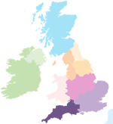
– July 2017

John Bloomer attends his first CIPFA Council & Presidents Dinner as CIPFA South West’s representative
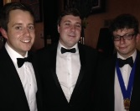The CIPFA Council meeting on Tuesday, 11 July, that starts off the CIPFA Conference each year, ahead of AGM, saw John’s first attendance, together with the President’s Dinner as our Rep. Here is John, with our own Will Tarrant from CSW Council, both from Cornwall CC, giving support to Chris Roberts, about to made CIPFA Students Network President the following day.
It was also Adam Broome’s last time, having been our previous Regional Rep on CIPFA Council. Seen here with Lisa Commane, who is one of the 3 Regional reps from CIPFA Midlands.
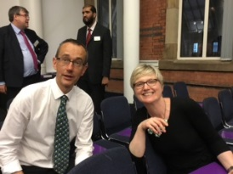

CIPFA SW members attend #CIPFA 2017
CIPFA SW sponsors several CSW members to attend CIPFA conference each year. Not everyone gets a chance to go as employers have limited training budgets, so involvement with CSW Region can open this up as an opportunity to see what goes on, form new friendships, meet up with old colleagues and get to hear from some fabulous speakers up close and personal. The exhibitors are always welcoming and share the latest products they offer, so you get to learn what’s current, what’s on trend, as well as pick up a few interesting freebies on offer!
There were some great speakers this year, and keynote sessions included preparing for Brexit Britain, Developing productivity and Human Capital, Tackling the Housing Crisis, Rebuilding Public Trust in Government and the Next generation CFO.
There were numerous workshops, and an excellent fringe event hosted by Past president Margaret Pratt, on Ethics ahead of the relaunch by CIPFA of its current Ethics Guidance. Anton Collela, the Chief Executive of ICAS spoke of “Moral Courage” being required, and Maggie Oliver, former DC at the Gter Manchester Police told her story of having to resign to whistle blow on her horrific experiences. More details can be found in Public Finance magazine
CIPFA South West gets social!
CIPFA SW is now on LinkedIn, Facebook and Twitter. Please follow us on at least one of these media, as it will help CSW keep you up to date with upcoming events, news and discussions that may be of interest to you as a CIPFA member. If you have any ideas on content or suggestions on groups we as a Region should be following then please get in touch.
CIPFA SW Students can also join the student group on Facebook to discuss student related matters such as exams, revisions and events.

CSW needs your help! We need you to:
- Support CSW Regional Council to be more representative – so we need more volunteers to sit on council and support us in supporting you!
- Help us communicate better with you, so if you are on LinkedIn, Facebook or Twitter – join our Groups, share your thoughts and tell us how we can support you more on networking, CPD, even just finding out what CIPFA is doing.
- Consider being our newsletter editor. Find the brief outline here of the role. Help us improve this newsletter. Contact us for more details, but it should not be a huge commitment but will be a real opportunity to make a difference to our members in CSW
- Help us in developing our area hubs in the south and north of our regions, based loosely around the Plymouth and Bristol areas. Christina recently emailed almost 300 members and students directly to appeal for support in creating a “West of England” hub to focus on Members in the area around Bristol, Bath and Swindon. If you don’t feel you have the time to commit to Regional council, why not be a member of one of our two hubs. Here is the link to a hub member brief, which gives you an overview of what is required.
Please message us on Facebook or email Joanna Hall if you are interested or if you would like more information and a chat

Student News
Representing students in your region offers valuable experience to improve your CV your and extend your networking across the country. You'll be involved with a range of activities, including:
- Sharing your views on courses or topics that are covered at events in your region
- Presenting student issues to the council
- Discussing ways of improving the student experience and support
- Organising student CPD and social events
If you're interested in being a student representative and you want to find out more about the role, please message us on Facebook or email Joanna Hall
Following the successful running for the first time in a long time of the CIPFA SW exam centre in Bristol, in collaboration with Grant Thornton, our cohort who took the Strategic level exams there have all been successful and passed! Well done ladies, and those of our students in the rest of the CSW region, let us know how you did via our facebook or twitter. We would love to know about your stories and journeys and come and join our CSW students group!
Bristol can be an excellent venue for our Strategic level exam takers, and means less travel at a very stressful time for students based in our glorious and beautiful Region. CSW are happy to support CIPFA run more in the future, knowing it will support, in a little way, our CIPFA members of the future.
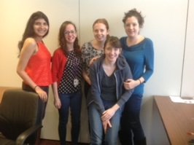
Well done, Sophie and Aditi from our Regional Council, here with some of their other colleagues from Grant Thornton.
Sophie Medwell
Our own Sophie recently stood down from CSW Regional Council to become Vice Chair of CIPFA Students Network, supporting Chris Roberts, who is now the Chair. Pictured above in the middle, she took up her role at the CSN on 12th July at the CIPFA Students Conference, following being the Hon Secretary of the CSN. Sophie, we wish you well, and you are more than welcome back to let us know what is going on, and how we can support you and the CSN.

Congratulations Christina!
Colleagues who attended our inaugural dinner in March will remember raising £103 at a raffle to support Christina’s planned Thames Path Marathon Walk. Well, she has now done it, in just short of 10 hours, raising £343 in total so far. She has sent a big shout out of thanks to all family, friends and colleagues who supported her!!
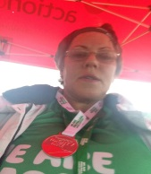
Let us know if we can support you doing anything similar, and tell us about it – we would love it if you would like to tell your story to our CSW family!

2018 events for your diaries
CIPFA SW AGM and Conference
16 March 2018, Torbay, venue TBC
CIPFA SW Annual Regional Dinner
18 May 2018, SS Great Britain, Bristol

Some of us oldies, including Christina, can remember the ship being dragged up the river by tugs in 1970 to its current home in Bristol Docks. See link here to the website, which gives you loads more details.

Full details of these events and bookings will be available soon on the South West regional page.

