CIPFA South West Region
Vice Presidents Blog – November 2017
Well, it’s been a busy last month for CIPFA business and in my new job – nearly two months in now.
Since my last blog, I have had a CIPFA Council meeting, an Ethics Working Group meeting and attended the Regional Autumn Forum and the CSE Region’s Annual Dinner as a guest of a good colleague of mine, Mark Williams, on the PA consulting Table. I will go into a bit more detail below. I have also been learning a little bit more about my new employers, the Institute for Apprenticeship, so I will mention a bit on that too.
CIPFA Council Meeting – 12 October – CIPFA Towers, London
Our CSW Regional Rep, John Bloomer, included an update of the meeting in our newsletter for October, so you can find that here, which is our full version copy that is archived on our website. Being a CIPFA Council Member is very fulfilling, and I can remember the pleasure and pride I got at finally getting elected back in 2010 after 5 different attempts at getting onto Council. It was Margaret Pratt, our first lady CIPFA President that urged me, and gave me the confidence to stand. Many solid volunteers never choose to be an elected Council member, and that is sad given the range of views I hear talking to them, but that never voiced at Council itself. Do please consider it, and represent the rank and file members of CIPFA. Let me know if you are keen to get that sort of exposure to strategic issues at Board level – you may not get that experience at in your workplace. Is excellent CPD and CV material, as well as ensuring member interests get represented.
For me what was valuable was Council agreeing that folk like myself who happen to have got elected to a represent a Region –in my case CSE (because that is where I live and work)– are automatically given a seat on that Regionals Council. Up to now I did not have the right, nor had I been invited to be included in CSE activity. In this day and age I think there will be more members working for multiple employers in locations around the world, never mind the UK. In my case I have been a member in 3 different Regions during my career of moving around the country as my career progressed. I would hate it if one of you had been off put committing to stand for CIPFA Council because you may need to move around the country for your career prospects.
We heard about the amazing ambitions Rob Whiteman and the CIPFA Board have for globalising CIPFA activities, and one of our very well respected Past Presidents, John Matheson, is heading up developing our International Strategy. It will be a challenge to ensure that UK activity does not slip, as we still have a predominance of members here in the UK that need support given the significant challenges we all face as a result of austerity and restrictions in public spending. But it was interesting to know that most of our students now for CIPFA PQ are non UK based!
Regional Autumn Forum – 6/7 November in Edinburgh
Took a couple of days leave to attend the Regional forum, representing Danny at the discussions held with Regional presidents on support for our Regional activity. It was agreed that a key link for each Region would be a Regional Manager. Some Regions are lucky to have quite active characters. CSW is currently covered by Richard Brereton, but this may yet change again by Xmas. He has met with leading Employers in CSW region but we were not included, so missed the opportunity to raise how our interests are mutual. Frustratingly, employers had mentioned their disappointment at a lack of activities in the CSW area; despite us seemingly not getting answers from colleagues we have contacted to sort such events locally! So we need CIPFA to help us join the dots. My email to over 300 members in the north of our area did not garner a lot of proactive offers of help, but I did get a good number of supportive comments to what we are trying to do. Please do let us know if you have a venue we could use as a base for an event!
What did get agreed was an annual event to bring together Regional activists, with more contact within the presidents of each Region to keep in touch regularly. We can all use the Regional forum – which is on the CIPFA website and link here - to exchange ideas or ask questions.

Opportunities with other professional bodies in our region
HFMA
I have finally made contact with someone in HFMA to look into some reciprocal arrangements and even joint events. That phone call happens soon, so I will update you in my next blog.
AAT - Dates I think may be of interest including:
6/12/12 Budget - Bournemouth and Poole branch. Let me know if you are interested in going.

The only Way is Ethics – CIPFA Ethics Working Group

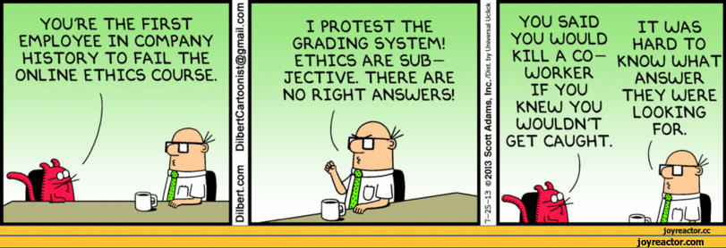
Chaired by Margaret Pratt, our first national lady CIPFA President, and the mentor who persuaded me that it would be worth standing for CIPFA Council (took me many attempts), we have finally agreed with CIPFA to hold a Round Table on 30th November. We want CIPFA members to really get involved in the debate about Ethics, considering so many of us at every level of our career either has, or is very likely to, be challenged, one way or another, to talk truth unto power, give messages we know our leaders don’t want to hear, and, possibly meet pressure to stay quiet where issues may need to be addressed. Over the years, I have found the strongest support being the network I have built up with CIPFA colleagues and friends, and not necessarily CIPFA HQ. But we on the Ethics Working Group believe that CIPFA can be more proactive, particularly given that challenges are continuing, and we seem to be at the forefront in supporting our leaders have to make priority decisions they don’t want to have to make – talk about kicking out to the nearest and dearest! So we will be discussion what can CIPFA HQ to act as a catalyst for support, what does it already do that may be enhanced to support us, and what can we do as individual CIPFA members and students to proactively support each other. I welcome your views and will tell you want happens and what is suggested.

Institute for Apprenticeships

I started working for the Institute on 2 October, as Head of Financial Management. It’s a Non Department Public Body, sponsored by the Department for Education. It’s taken on previous activities undertaken by the DfE and the Education and Skills Funding Agency, when it was set up and launched on 1st April 2017. Whilst it does not manage the Apprenticeship Levy (that’s the HMRC), it manages the set-up of new Apprenticeships and their standards, ensuing that the qualification that the apprentice receives is relevant and of the correct standard, whether it is level 3, level 4 (which is AAT) or level 7, which is chartered status like we have as fully qualified CIPFA members. Happy to tell you more about them, and the work I did in supporting the development of the Level3, level 4 and level 7 trailblazer for Accountants. Just about to recruit one of my own for AAT level 4. And did you know CIPFA CETC, CIPFA own trailing provider, also trains AAT?
We are into autumn good and proper now, so keep warm and dry!
Best wishes,

Christina

Twitter – search twitter.com/CipfaSW
LinkedIn – search for the Group CIPFA South West
Facebook – search for the Group CIPFA South West

