Call for evidence on the future structure of the LGPS
Submission from Gloucestershire County Council as the administering authority of the Gloucestershire LGPS.
Q1 – How can the LGPS best achieve a high level of accountability to local taxpayers and other interested parties- including through the availability of transparent and comparable data on costs and income – while adapting to become more efficient and to promote stronger investment performance?
Accountability to local taxpayers and other interested parties in Gloucestershire is facilitated by having a locally based administering authority made up of locally elected representatives, an annual Pension Fund report and annual meeting open to all scheme members and interested parties, plus regular meetings (at least every 6 months) and communications with all the Gloucestershire scheme employers. Feedback from employers (via an annual survey and summarised in the Fund’s Annual Report) has shown that face to face discussions helps improve communication and understanding of the roles and duties of scheme employers. Also, the number of employers per LGPS Fund is increasing each year. According to the CIPFA Pensions Benchmarking Survey 2013, the average number of employers in an LGPS Fund is now 163 (in Gloucestershire there are 178). Given the diversity of employer types within the LGPS and their increasing numbers (an increase of 30% in Gloucestershire over the last 3 years), this local communication will become more important, particularly given the requirements on employers to maintain and provide more information relating to career average salaries from April 2014.
Data published by all Funds needs to be compiled using standard assumptions. However different firms of actuaries currently use different financial assumptions for determining the discount rate when calculating funding levels and deficits for LGPS Funds. As a result these funding levels and deficit levels cannot be compared across all Funds.

We believe a common assumption basis could be set by the Government Actuary Department (GAD) which could then be applied purely for comparison purposes.

Also, not all LGPS Funds identify all their investment manager fees, in for example, the SF3 return and their annual accounts. Many Funds do not include those management fees which are not invoiced to the Fund but are deducted directly by the investment manager from the value of the investment portfolio which they are managing. This generally occurs with investments held in pooled rather than segregated funds. The Gloucestershire Fund does reflect these charges, which are deducted at source, in its accounts and returns, when identifying investment manager fees, but based on informal discussions with other LGPS Funds, we believe that the majority of Funds do not make these adjustments.
Also, where returns such as the SF3 are to be used to measure fund management and administration costs, very clear guidance needs to be provided to ensure consistency of reporting across all Funds. To help ensure consistency of reporting it would be helpful if the processes followed in completing key returns were verified by the Funds’ external auditors or possibly, the new Scheme Advisory Board .
The Gloucestershire Fund participates in the Framework Contracts developed by the LGPS funds in the South West over recent years. These frameworks cover pension legal services, actuarial and benefit consultancy services and investment consultancy services. By joint working via these frameworks there are savings in both procurement costs and ongoing costs (the saving from the actuarial and benefit consultancy services and investment consultancy services contracts joint procurement exercise was estimated at £400,000 spread across the 7 participating LGPS Funds) with an ongoing estimated saving of 10% on payments under these frameworks. The Gloucestershire Fund has also expressed an interest in other national framework contracts such as the one currently being developed for Global Custody services.
The Gloucestershire Fund has consistently been one of the lowest cost Funds for providing Pension Administration, based on the annual CIPFA Benchmarking survey. This is mainly due to keeping staff levels at a minimum while maximising use of electronic efficiencies, e.g. transferring data from employers directly into the Fund’s pension administration system. Gloucestershire is aware of a few LGPS Funds who are combining pension administration functions and will continue to monitor the benefits of this approach. However based on data currently available (eg via the SF3 return) there is no evidence that this approach can reduce costs. Similarly the SF3 return does not show that larger Funds, such as the London Pension Fund Authority (LPFA) have a lower administration cost per member than smaller Funds. In fact the LPFA costs are higher than those of smaller Funds.
While it is important to monitor and keep internal administration costs to a minimum the largest area of cost for LGPS Funds are investment fees. The Gloucestershire Fund has focussed on keeping all fees as low as possible and the investment fee for the whole Fund is 25.6 basis points. This compares to an estimated 55 basis point for a typical LGPS Fund, based on figures produced by Hymans Robertson (copy attached) using a typical LGPS Fund asset split provided by the WM company, (who monitor the performance of LGPS Funds).
Hymans Robertson, who are the actuaries for the Gloucestershire Fund, have co-sponsored some research by the world's leading independent benchmarking company CEM Benchmarking Inc which has compared the total investment costs of a sample of 12 LGPS Funds (which is representative of the LGPS as a whole with small, mid sized and large Funds) totalling circa £30bn, with an international peer group of twenty funds of similar size (£30bn) and a comparable investment mix. The difference between these combined LGPS Funds and the £30bn peer group Funds is just 5 basis points per annum. This shows that on average the LGPS Funds in the sample are paying investment manager fees similar to those of Funds 10 times bigger and provides evidence that by simply combining LGPS Funds by merger will not result in lower fees.
The Gloucestershire Fund believes that any further efficiencies in fees can most effectively be obtained by voluntary joint procurement exercises across Funds when appointing a new manager for a particular asset class. Proposals for this approach have been discussed with other LGPS Funds in the South West and we understand the Society of County Treasurers (SCT) are developing a standard process to be used for this approach.

Q2 –Are the high level objectives listed (ie Dealing with deficits and Improving investment returns) those we should be focussing on and why? If not, what objectives should be the focus of reform and why? How should success against these objectives be measured?
We agree that identifying the most cost effective way of dealing with deficits and ensuring investment returns are maximised are key objectives.
As already stated, the measurement of deficit levels needs to be consistent and based on standard procedures and assumptions across all LGPS Funds. If this does not happen, varying levels of prudence in actuarial assumptions will produce a higher discount rate makes it difficult to compare deficits on a like for like basis.
By merging Funds the total deficit level of these Funds will remain the same. Therefore Fund mergers will not in itself impact on defict levels.
The WM Company advise the Gloucestershire Fund on performance and have access to data from the other LGPS Funds. In the following graph they have analysed the performance of LGPS Funds over the past 10 years. The orange dots show the 4 largest Funds and the blue dots show the 4 smallest Funds. This shows there is no evidence that larger Funds will necessarily produce a better level of return than smaller Funds. 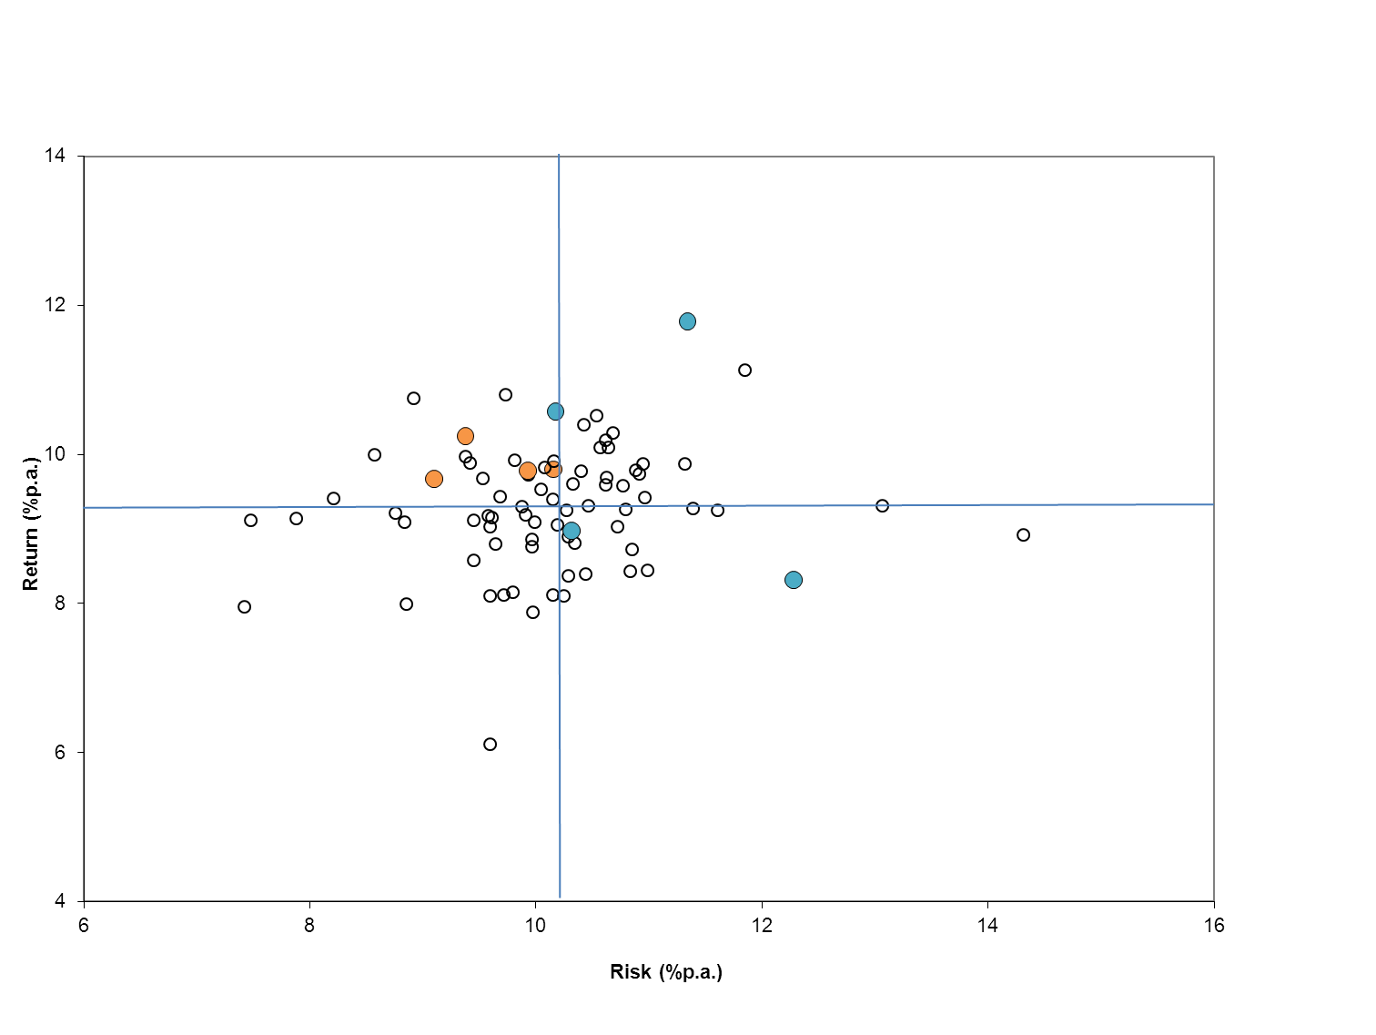
Hymans Robertson have also identified average LGPS Fund investment returns for England and Wales over 5 years (copy attached) which also shows there is no correlation between Fund size and the level of their investment return.

Q3 – What options for reform would best meet the high level objectives and why?
A standard set of assumptions for identifying and comparing deficits would prevent the use of more optimistic assumptions to “mask” underlying deficits. There is a danger that adopting more optimistic assumptions without proper consideration of the increased risks that are being undertaken could lead to an inadequate contribution plan for repayment of the deficit. Requiring Funds to demonstrate the credibility of their funding plans and presenting a risk-based assessment of their pension obligations would improve the deficit management objective. However, this need not prevent the Funds adopting different more Fund specific assumptions, but would assist regulatory oversight.
As already indicated in our answer to Question 2, merging Funds does not reduce deficits. Also, the existence of deficits is not a sign of mismanagement. In fact the existence of deficits is a common feature of defined benefit schemes across the world.
Fund performance and managing employer contributions are the key factors in addressing deficit reduction. This is best approached by local consultation with employers and voluntary joint working and joint procurement exercises for fund managers including asset pooling through joint investment vehicles while retaining the proven investment strategies of individual Funds, with local accountability and governance arrangements. This voluntary approach would also avoid the costs incurred if Funds had to terminate existing investment management agreements as a result of an enforced merger.
However it is critical that transparency of Fund performance and employer pension contribution rates is improved. Both can vary considerably and in the case of employer pension fund contribution rates will impact on service costs and can undermine the accurate comparison of costs. Variability in employer contribution rates is also difficult to explain across Pension Fund boundaries, typically where different firms of actuaries have made different assumptions. This is particularly important where there are shared service arrangements across Fund boundaries.

Q4 – To what extent would the objectives you have proposed under question 3 meet any or all of the secondary objectives? Are there any other secondary objectives that should be included and why?
Some of the secondary objectives (ie, to reduce investment fees, improve flexibility of investment strategies, improve cost effectiveness of administration, provide access to higher quality staffing resources) are clearly beneficial and our proposals to help address these are as follows:
The joint working proposals outlined in the answers to both Q3 and the other questions would help reduce investment fees and could also help improve flexibility of investment strategies by further sharing of good investment strategies between Funds. However the evidence from the research carried out by the world's leading independent benchmarking company CEM Benchmarking Inc (as detailed in the answer to Question 1) indicates that LGPS Funds already achieve very competitive investment fees, comparable to those paid by large (£30bn) size Funds.
The sharing of cost data which is produced on a consistent basis across all Funds will help identify what is cost effective in terms of Fund administration.
In relation to providing access to quality staffing resources, joint working between Funds can also help provide more resiliance and shared expertise.
On the other hand, two of the secondary objectives (greater investment in infrastructure and providing more in-house investment resource) are not necessarily beneficial.
Investment in infrastructure is just another asset class and should only be invested in as part of a balanced investment strategy as long as the returns versus the costs and risks warrant it.
Also, more in-house investment resource may not be necessary as for example, a passive portfolio managed in house by one Fund could be opened up to other Funds on a shared cost basis.

Q5 – What data is required in order to better assess the current position of the LGPS, the individual Scheme fund authorities and the options proposed under this call for evidence? How could such data be best produced, collated and analysed?
As outlined in the answers to the above questions, there needs to be consistent methods of data collection across all LGPS Funds with the method of calculating key data being independently verified. Also, funding levels and deficits should be compared using standard financial assumptions.

