CIPFA North West Society



**Presidents Blog – March 2016**

One year in to my Presidential role and I’ve really enjoyed every minute of it. I always so it but I really can’t believe how quickly it’s gone. It’s been a fabulous year and I’ve attended some excellent functions and met lots of lovely and interesting people.

My aspirations for the past 12 months have been met, in part but I still have some work to do for the coming 12 months. During the year we have re-established a Retired Members group but have yet to hold an event – I’m hoping that our first event will be in July before the National AGM. We have made progress with our twinning and mentoring ambitions but are yet to understand how this will fully work, and we’ll be working on this during the year. Our Student Network has been re-invigorated with the help of Carol and Liga and as Liga steps down as Student President, I am confident that the high standard she set will continue. So, lots of achievements during the past year that I am really proud of but still a lot more to do.

We held our AGM and Spring Seminar at the Pyramid Theatre in Warrington. We had a few co-opted Members formally being elected to Society Council plus a newly elected Corporate Member. Our new Corporate Members are listed below and really boost the CIPFA North West Council membership. We have a great gang of volunteers in the North West and it’s a good job as we wouldn’t be able to support members and students in the way we do with our events without them, and I certainly wouldn’t be able to as an effective President on my own. We also have a change of Secretary as Mike Thomas stepped so that Nick Atlay could take over the reins. Mike has been an excellent Secretary and I’ll be sorry to see him go. However as he is Vice-President he won’t actually be going anywhere for at least 3 years yet!

**New Corporate Members of Society Council**

Jeremy Valentine

Mike Owen

Rebecca Davis

Liga Berzina

Stephanie Donaldson

Carol McDonnell

Simon Rafaelli

Steve Freeman

We had two superb speakers at the event, John Matheson, CIPFA President and former Director of Finance at NHS Scotland spoke about the health and wellbeing agenda in Scotland and the impact it is having on the public services. He also talked about what CIPFA has been doing over the past 12 months and what we can expect for the future. I could have listened to John speak all day and so could the audience if their reactions were anything to go by. I was actually with John the evening before at the CIPFA Scotland Conference where I was invited to speak in my organisations capacity. John opened his speech by letting everyone know that the last time he saw me the night before I had an inflatable hammer and microphone on my person. And there was I trying to look professional having surfaced at 6.30am for the 8am train from Glasgow following a (very) late night.

Our second speaker was Sharon Senior, Assistant Director - Development, from North West Employers. Sharon gave an excellent and interactive presentation on emotional intelligence, getting us to consider our own management styles and why we need to change them in different situations. The presentation generated some great debate and questions from the audience and considering it was 4pm on a Friday, no one was making any move to go home! NW Employers will be speaking at two other events we are holding this year – the regional event on 12 July, before the CIPFA National AGM in Manchester and our Regional Conference in November.

I mentioned the CIPFA Scotland conference briefly earlier and although I wasn’t attending as NW President, I have to say what a fantastic and well organised event it was. I did manage to catch up with some CIPFA colleagues who were also there though, some from Scotland that I haven’t seen for ages. And just to prove John was right, here I am with the said inflatables, and of course one of John in his Scots best.

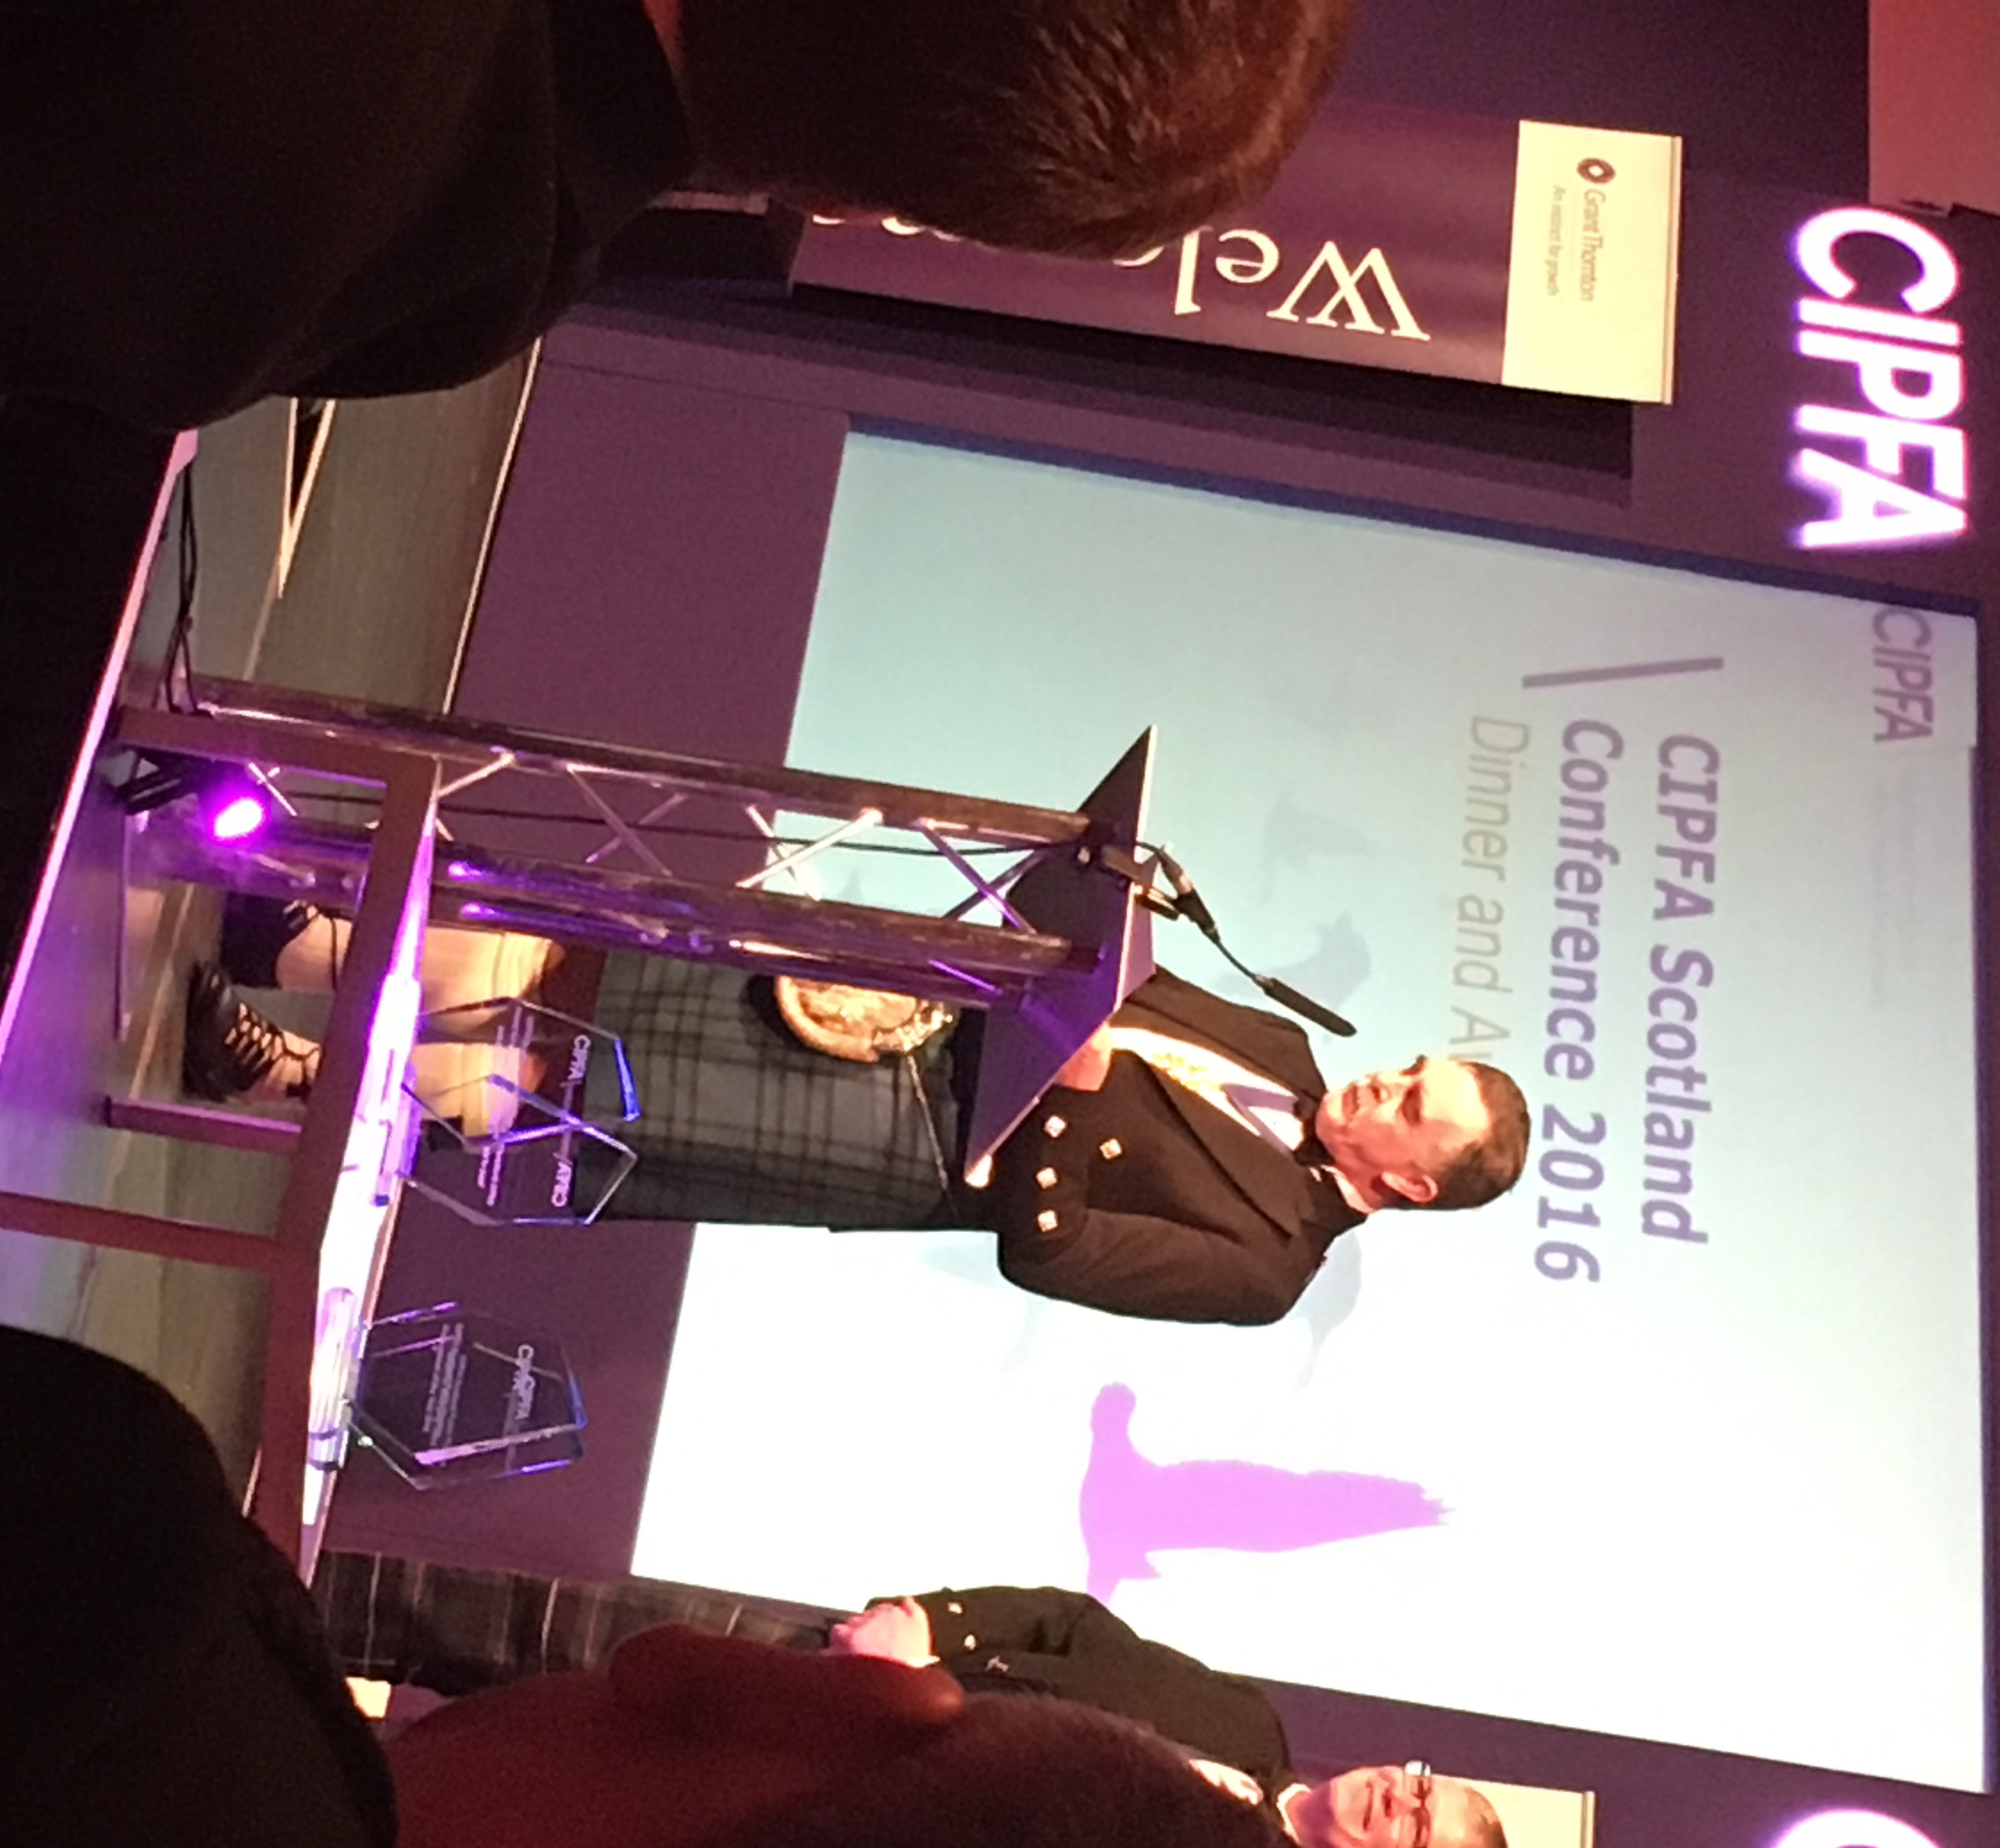

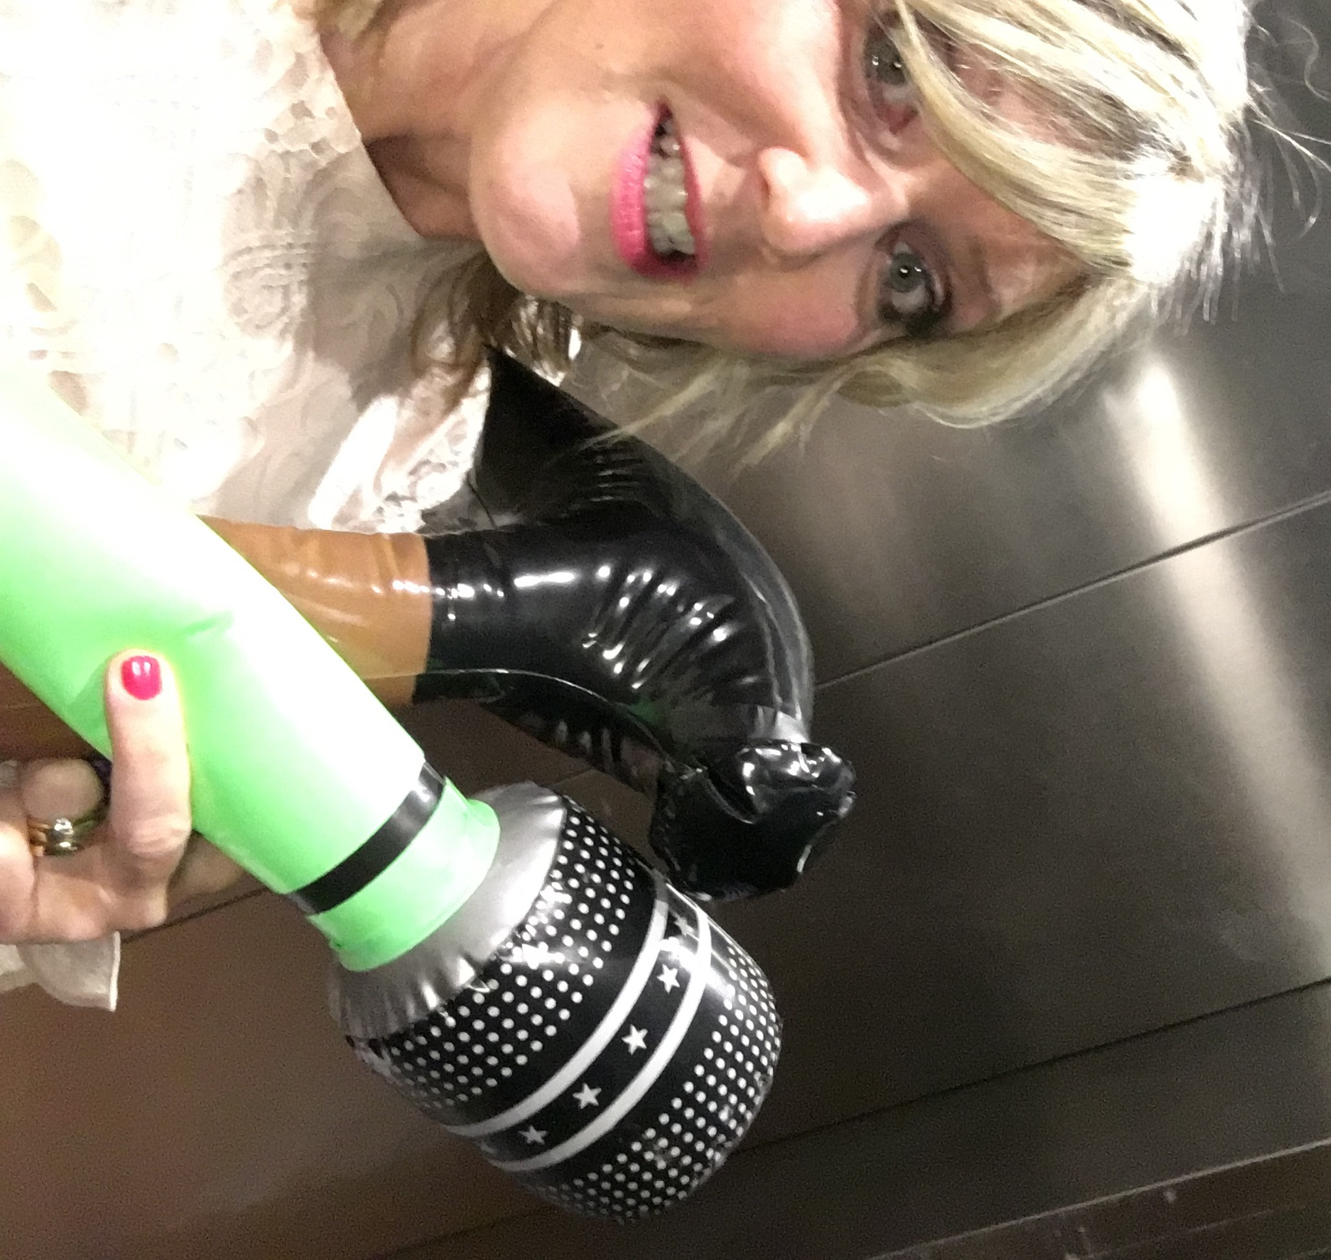

**And finally…..**

Tough Mudder update – After vowing to spend the whole of Easter either running, cycling or walking mountains, the whole team more or less spent the whole time in the pub. (Talking tactics of course) However having left my job for pastures new in March I was asked by my former colleagues what I’d like as a leaving present, having refused to get me what I asked for - a big tyre and a huge length of rope (see, I am trying) they gave me the cash to buy it myself ☺ Must try and train harder for April, although I have found a fellow experienced ‘mudder’ in my new organisation so I’ll be tapping him up for some hints and tips.

Shaer

**Twitter –** search [twitter.com/CIPFANW](https://twitter.com/CIPFANW)

**LinkedIn –** search for the Group CIPFA North West

**Facebook –** search for the Group CIPFA North West

**CIPFA Website -** http://www.cipfa.org/members/regions/north-west