CIPFA North West Society



**Presidents Blog – July 2015**

Well I think we can definitely say that summer arrived and went during June & July. I loved that everyone was delighted that we had some sun for then only to wish it would go away a couple of days later because it was too hot! We are a funny bunch but we wouldn’t have it any other way. An old colleague of mine used to say “there’s no such thing as bad weather, just bad clothing” As a result I now go round with sunglasses, umbrella and gloves in my handbag all year round.

The main event this month was of course the Annual Conference. I was really looking forward to it and wasn’t disappointed; it was a really brilliant full packed 3 days. The conference programme was excellent with excellent speakers and exhibitors. I got to catch up with lots of people I hadn’t seen in ages and also met lots of new contacts, including some delegates from Japan!

I spent one day helping out on the regional stand which was hosted by CIPFA South East, this meant being on hand to answer any queries from delegates on regional items and to alert them to the regional events programme going on throughout the year. It also included being positioned on a street corner for 2 hours in a smashing purple CIPFA polo shirt holding a CIPFA umbrella directing people to the conference venue. The weather held out and it was actually good fun. Since I did such a good job I was then given the task of again being out on the street once the conference had finished with a huge sign to direct people to the regional drinks reception. I think I’ve missed my vocation….

Check out the photos on the Twitter and Facebook site from the conference.

Next year the Conference is coming to Manchester. I’m already super excited and have been recruiting new Council members in readiness to help out to make sure we can replicate the excellent hospitality of the South East region over the past two years. At our meeting on 17 July North West Council co-opted the following people onto the Council Executive:

* Steve Freeman – Chief Finance Officer, PCC for Lancashire to represent blue light services
* Mike Owen – Chief Executive , Bury Council to represent Local Government
* Stephen Jones from the Manchester branch of the AAT
* Carol McDonnell – Group Auditor, St Helens Council
* Simon Rafaelli –Head of PMO, University Hospitals of Morecambe Bay NHS FT to represent Health

The NW Council have been busy behind the scenes cracking on with the organisation of the Regional Conference and Annual Dinner on 13 November. Our venue is the Crowne Plaza hotel at Speke Aerodrome and I’ll be starting to get some comms out about it in August so watch out for it on the website and hopefully I’ll include a link to it in next month’s blog. We already have some speakers lined up and it won’t be long before they’re all agreed

As a heads up any new members accepted into the Institute during the year will be receiving a complimentary invitation to attend the dinner to formally have their membership certificates presented so keep the date free. We also have some great entertainment planned.

We’re planning on holding a student breakout session at the Conference and I think I already mentioned that we have booked Aimee Bateman from Careercake.com to speak. We’re also planning to have someone from CIPFA to talk about the new e-assessments for the professional qualification that start this year which will impact on all students so save the date to ensure you will be fully up to speed with the new requirements. Students will be half price to attend so a note to all employers, this is a sessions that can’t afford to be missed

Not sure if anyone saw the interview with Bill Shields last month on the CIPFA Thinks page? <http://www.cipfa.org/CIPFA-Thinks/Health/Articles/Bill-Shields-interview.aspx>. It was really interesting to read an insight into health finance from the Chief Exec as local government and the NHS do speak a different language sometimes when it comes to finances. I am working with colleagues in the North West to arrange some training events for health and local government with the support of CIPFA, to try and understand the differences and how they impact on each other, especially in light of the devolution agenda. I’ll keep you posted on how we get on.

**North West CIPFA Student Network Re-launch**

I was absolutely delighted to have been asked to speak at the re-launch of the North West CSN event in Manchester on 3 July. There were two other brilliant speakers on the bill, Karen Kelly from Edinburgh Council and Jayne Stephenson from GMPCC.

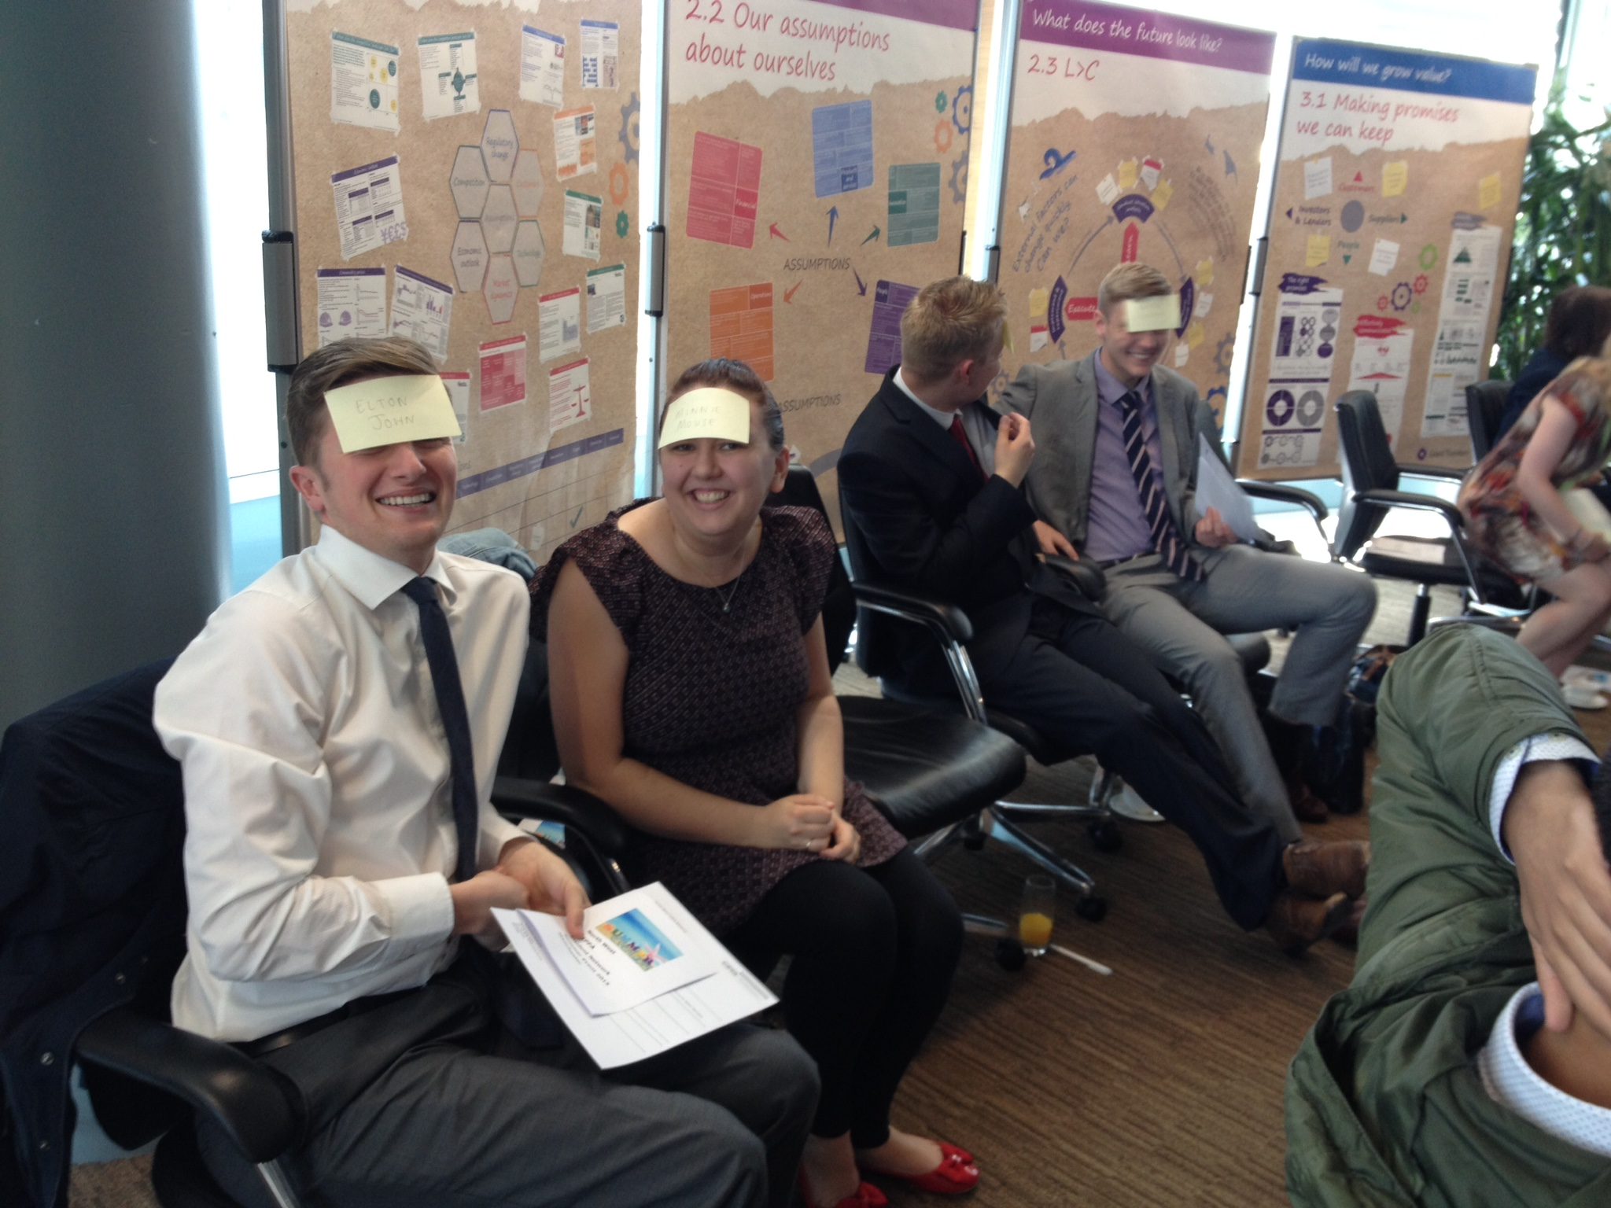

Congratulations to the CSN for hosting a great event under new President, Liga Berzina. The students were really engaging and I look forward to seeing what else is next on their events calendar. The ice breaker was great fun too - having to guess who we were from the names on post it notes on our heads. Grant Thornton enabled the CSN to hold the event at their offices so a great shout out to them for their ongoing support.

**<<<** See how thrilled they were to pose for the photo with Post-it notes on their heads

And finally, at the end of May I completed my 100km through London during the night for three cancer charities. It was really enjoyable for the first 40 miles and then started to get a bit tough, with the last 10 miles a real killer. It didn’t help that it rained half way and then didn’t stop; but one of the highlights was stopping at Buckingham Palace for a water top-up at 3am. I felt a real sense of satisfaction and pride and so rewarded myself with a little 4 day break in Ibiza, nothing like the thought of a beach and a cocktail to keep you going ☺.

Next month I am off to climb Helvellyn in the Lake District with some friends, although I have tried everything I possibly can to get out of it but they’re not having any of it. Looks like I’ll have to dust off my walking boots then. Bah.

Shaer

**Twitter –** search [twitter.com/CIPFANW](https://twitter.com/CIPFANW)

**LinkedIn –** search for the Group CIPFA North West

**Facebook –** search for the Group CIPFA North West