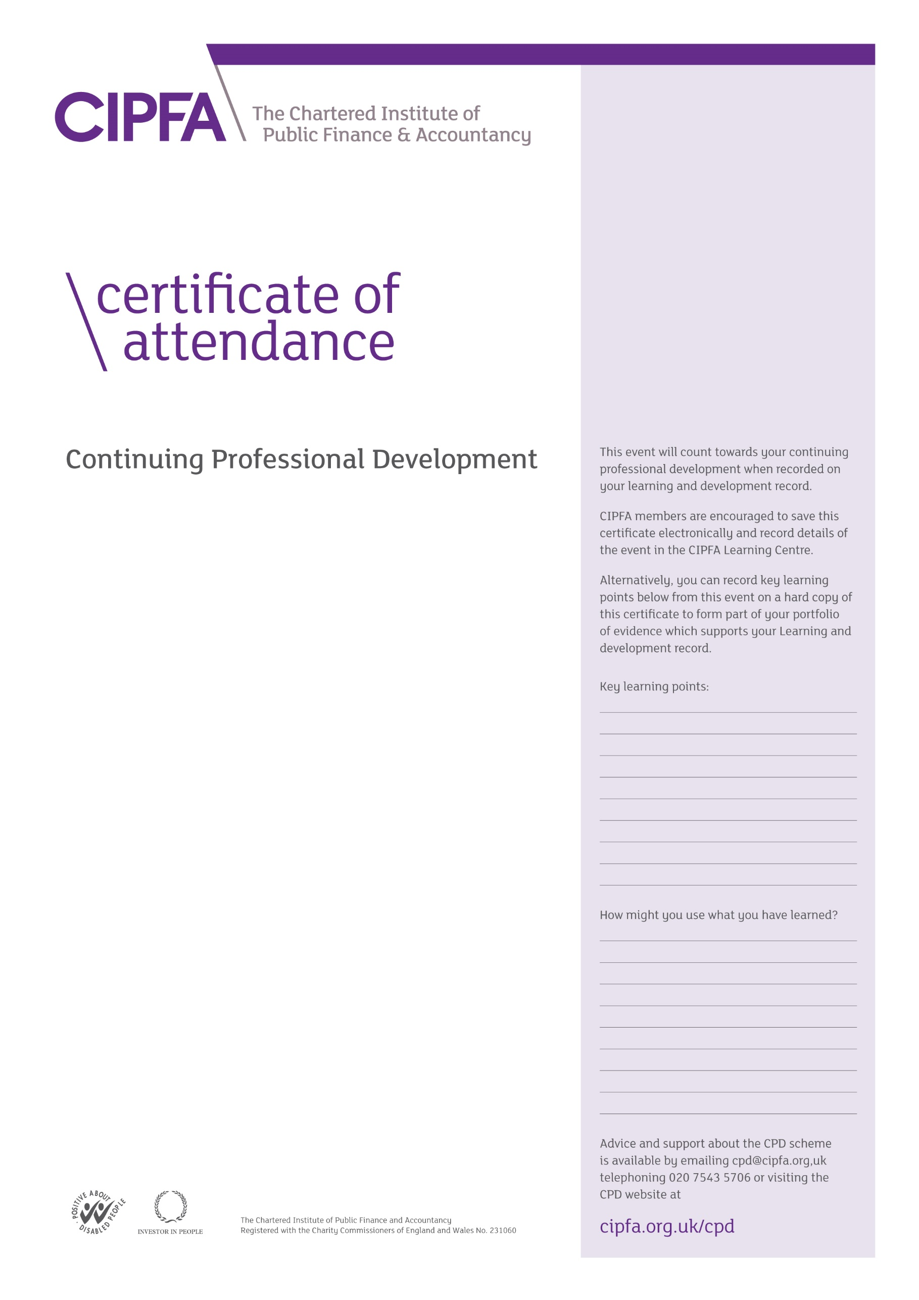

CIPFA South East Region Digital CPD

13 October 2020 1.30pm – 3.00pm

Climate change and carbon reduction –

projects, funding sources and

business cases

Presentations by

Mark Williams & Angelos Vouros

It is for the individual to determine the relevance and amount of time that this event counts towards their CPD

This certificate will be validated by reference to the delegate attendance list maintained by CIPFA for this event.