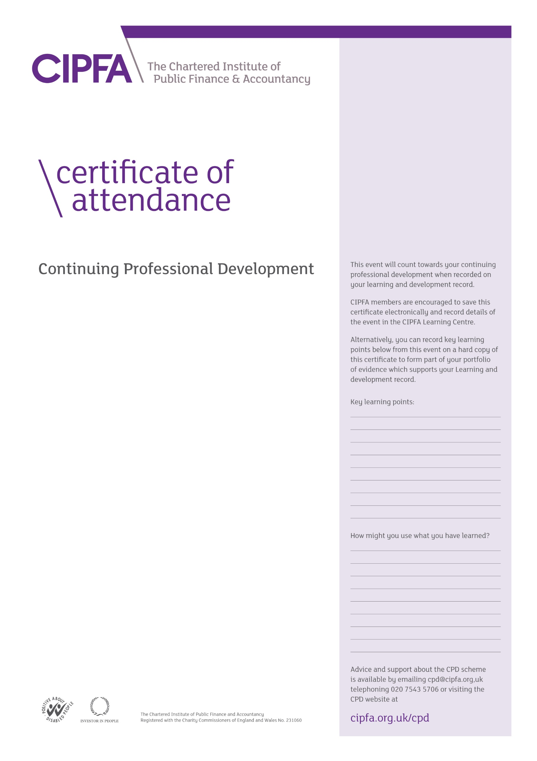

CIPFA South East Region Digital CPD

15 October 2020 1.30pm – 3.00pm

*Climate Emergency – a practical solution with some innovative financial options*

*for local authorities*

Presentations by

Thomas Minter, Malaby Biogas

Roy Nolan, Andrew Hinds and

Shane O’Neill, RP Martin

It is for the individual to determine the relevance and amount of time that this event counts towards their CPD

This certificate will be validated by reference to the delegate attendance list maintained by CIPFA for this event.