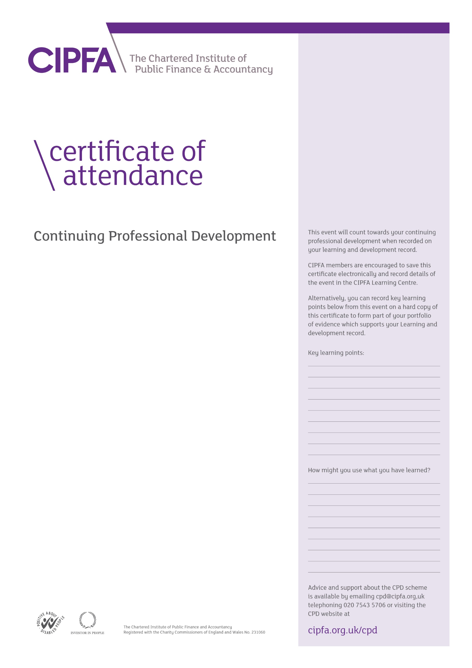

CIPFA South East Region Digital CPD

21 September 2020 1.30pm – 3.00pm

Presentations by

Alexandra Bedford – Zurich Municipal

Mark Davies and Kelly Watson - CCLA





It is for the individual to determine the relevance and amount of time that this event counts towards their CPD

This certificate will be validated by reference to the delegate attendance list maintained by CIPFA for this event.