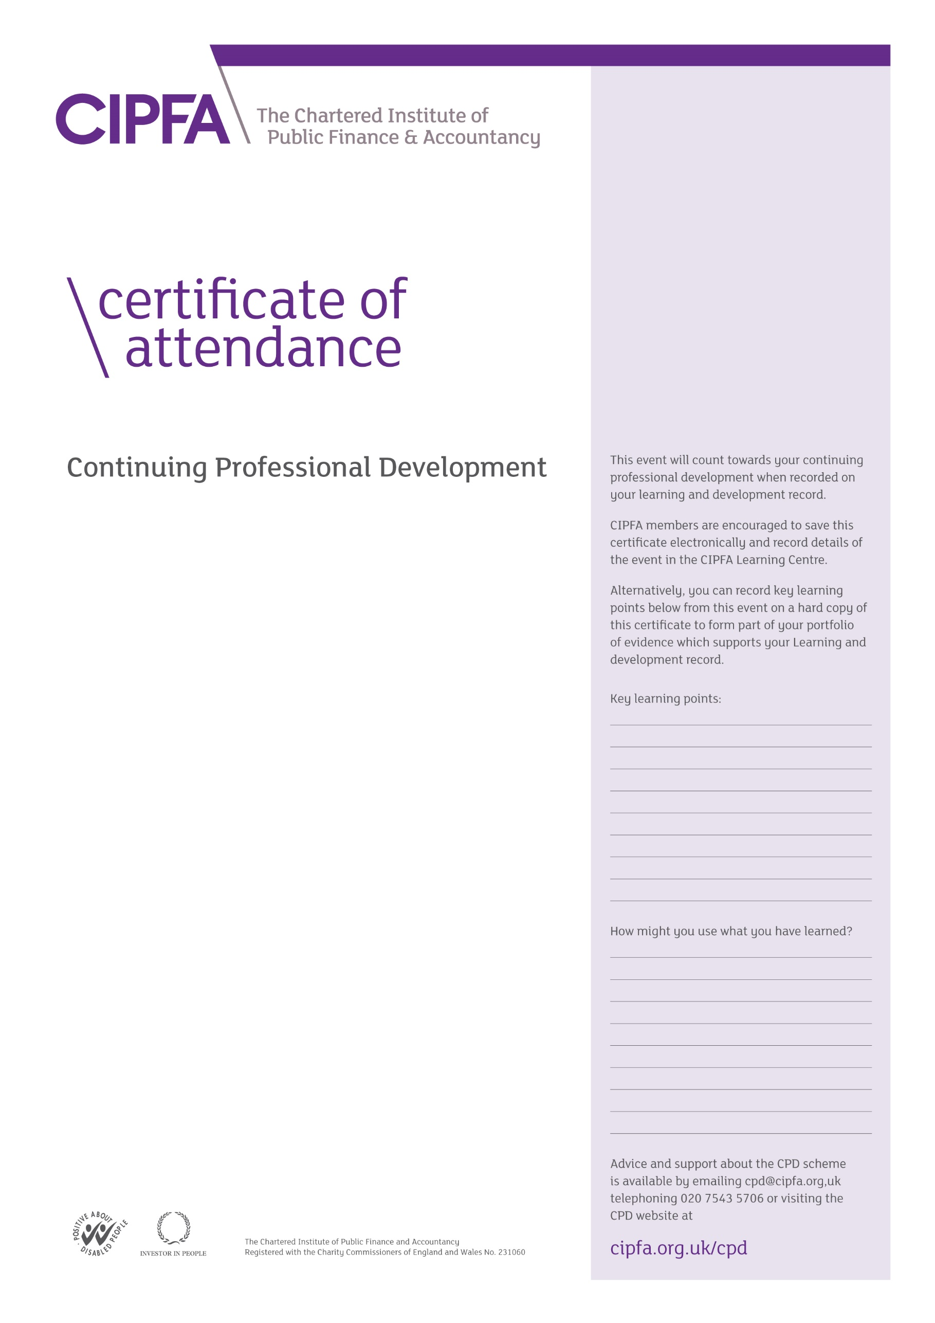

CIPFA South East Region Digital CPD

12 March 2021

Budget 2021: What did we learn?

‘Levelling Up’ – an introduction

Ben Zaranko,

Research Economist,

Institute for Fiscal Studies

It is for the individual to determine the relevance and amount of time that this event counts towards their CPD

This certificate will be validated by reference to the delegate attendance list maintained by CIPFA for this event.