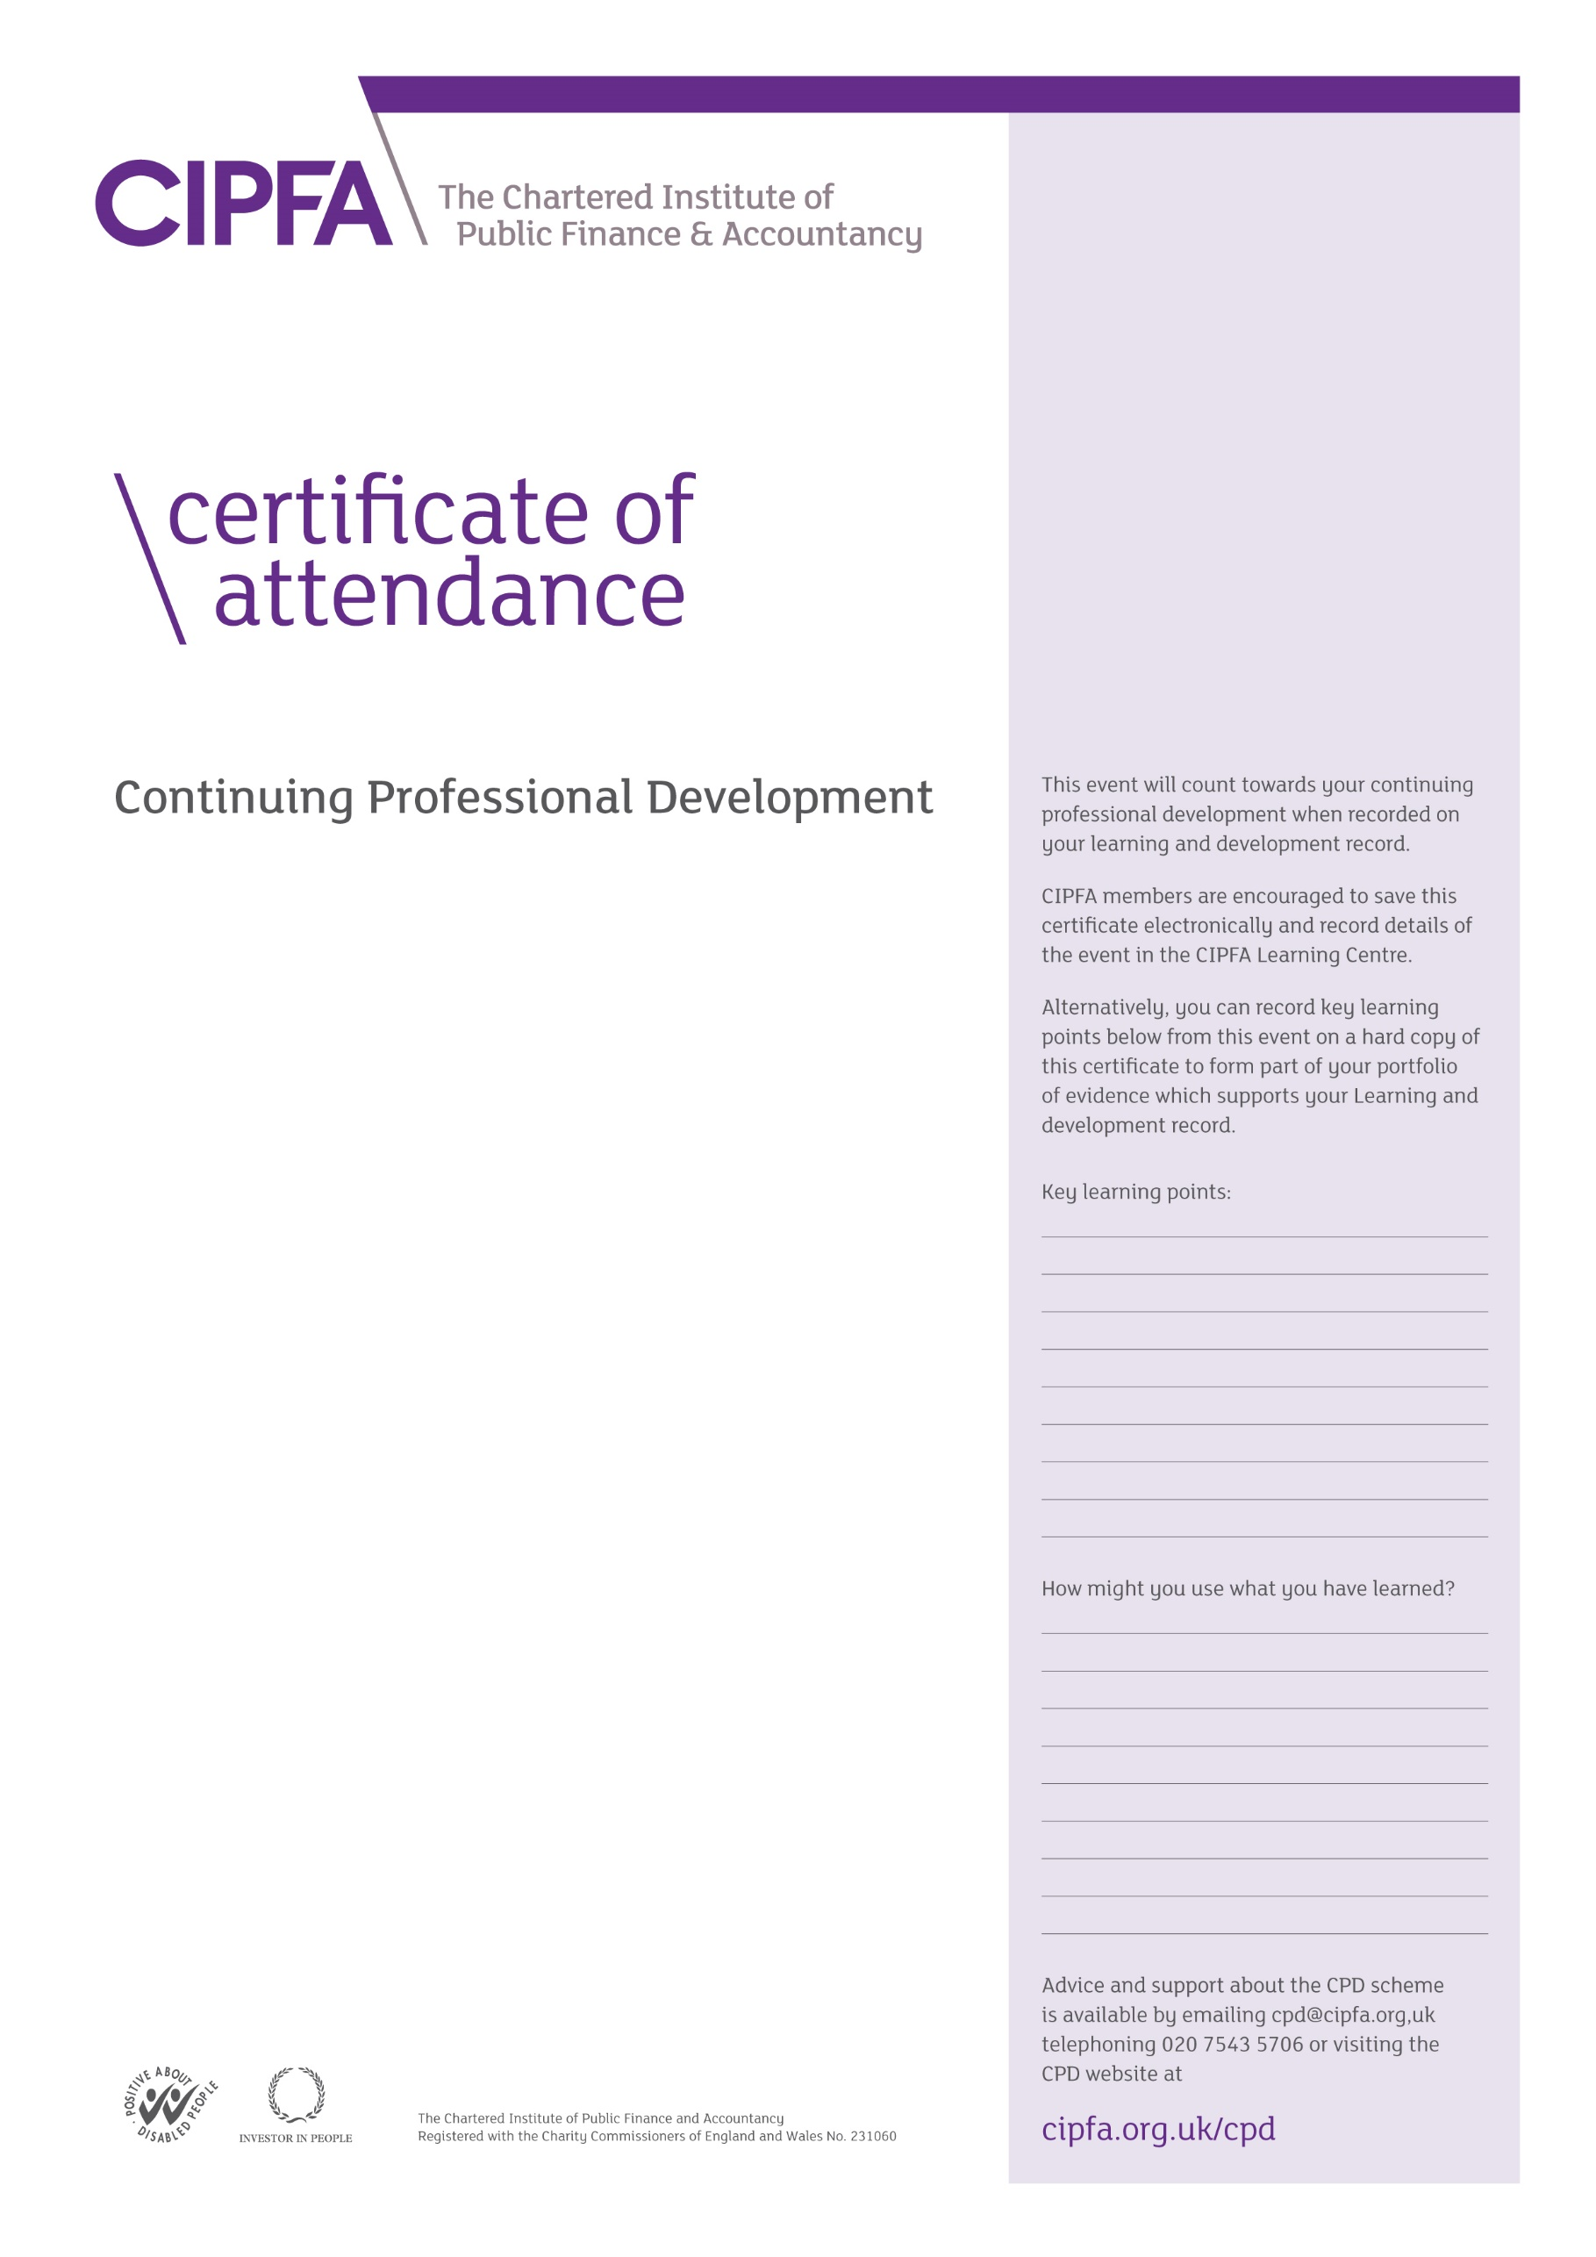

**CIPFA South East Region**

**Essex Hub Group Meeting**

**19 January 2023**

**at**

**Essex County Council**

**County Hall, Market Road, Chelmsford CM1 1QH**

It is for the individual to determine the relevance and amount of time that this event counts towards their CPD