CIPFA South West Region
Vice Presidents Blog – July 2017

Wow, it’s been one busy couple of months since I became CSW VP, supporting Danny Batten our President. I thought it may be fun to take to doing a blog, mainly about progressing work with CIPFA South West, but also a whole lot of other stuff I do. My volunteering position in CIPFA has stemmed from me being granted support to become a CIPFA student all those years ago at Oxford City Council. No doubt I will mention a few names from those days, but this time in particular, it’s David Magor. David appointed me at Oxford as Principle Revenues Officer, back in 1985 after I passed my RVA exams. This opportunity led to my transfer to Accounting and training for CIPFA with CETC in the days it was at Croydon (and over the weekend!). Here he is now after I bumped into him for the second time this year at the CIPFA President’s dinner in Manchester. The first time was in March at the AAT Annual lunch. He is invited in his now day job capacity as the Chief Executive of the IRRV, and which I go to each year in my capacity as CIPFA nominated co-optee onto AAT Council, which I have been very lucky to have done since 2012. Can’t say I have any photos from when I worked for him 32 years ago, but just goes to show how networks work, and you never know when you may meet work colleagues when you get as old as me!!!
David Magor, CEO of the IRRV and myself at CIPFA President's Dinner in Manchester
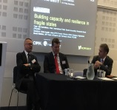
On a different note, some of you may be aware of the various panels and other activities that CIPFA offers for volunteers to get involved with. These were some of the things I did after qualifying. My favourite panels are the Accounting and Auditing Standards Panel (or AASP), chaired by the wonderful David Watkins, pictured here presenting an excellent workshop session at CIPFA Conference with Ian Carruthers and Chris Austin, and the Financial Management Panel. But the one I have had the most consistent involvement in is the TIS online stream I am on that is chaired by Ian Coleman, and is now called the Financial Management and Corporate Governance Panel, and I have been on that since the early 1990s!
Ian Coleman
From left to right: David Watkins, Chris Austin and Ian Carruthers
They are very different from being involved as a volunteer at a Regional level, and offer brilliant CPD opportunities, as well as forming great network contacts. The work we do on these panels is hidden, and not celebrated enough by CIPFA as a whole, but I will try to do more of that, and would welcome knowing any one of our CSW members who are involved, and highly recommend any of our members to get involved. The TIS online stream I work on is looking for a few more volunteers, especially colleagues in health and to support me re Central government. And I saw in the last spreadsheet that there are plenty of openings across the whole range of TIS online. And you get access to the wonderful material, which is of particular support to me working for an employer who does not subscribe.

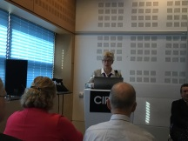
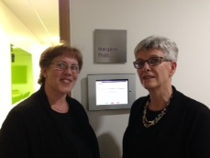
The most recent group I have been involved with is the CIPFA Ethics Working Group, chaired by the first lady to become CIPFA President, Margaret Pratt. Here I am with her outside the room named after her at CIPFA HQ in Mansell Street, and opening the workshop she chaired on Ethics at CIPFA Conference. The Working Group is updating CIPFA’s guidance on the Ethics Statement of Professional Practice (SOPP), and is sharing some eye opening case studies, and hearing of real life ethical dilemmas. I would like to make sure we have an event in CSW that covers this very important area within the next year.
Myself with Margaret Pratt outside the room named after her at CIPFA HQ

Margaret Pratt speaking at CIPFA conference 2017 breakfast Ethics workshop event

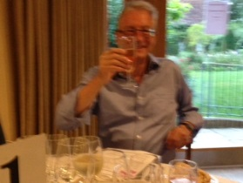
Forging great links with AAT in the SW
John Thornton at English Wine Centre & Cuckmere Barns
On a final note, I want to share some of my work with AAT, as I spent a brilliant 3 days with AAT Council and staff in Eastbourne last week on AAT business and finishing off with our formal Council meeting. I have been on AAT Council as a CIPFA rep since 2012, and whilst that formal link is now severed with all the Accounting Bodies following a recent governance review, my fellow CIPFA colleagues John Thornton and Jane Cuthbertson and I will be involved till at least September 2018 as co-opted independent members. We have had many CIPFA members who started their accountancy careers studying AAT, and some have proudly continued their membership. CSW don’t have any records for our members who either did AAT or are currently AAT members, but let us know. The reason I mention this is because I have developed some great relationships with AAT branches in the CSW area, and want to firstly ensure we have some great joint events, but secondly to enhance shared opportunities for AAT members - particularly those working in the public sector - to feel welcome at CIPFA events and offer any of our CIPFA members the opportunity to attend AAT meetings. Here is John Thornton at the fabulous Dinner we had at the English Wine Centre. Watch this space for more news on joint events on our website.

Christina

Twitter – search twitter.com/CipfaSW
LinkedIn – search for the Group CIPFA South West
Facebook – search for the Group CIPFA South West

