What’s on in CIPFA South West 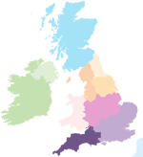
– September 2017

CIPFA SW Committee – 13th September
The latest CIPFA South West Committee meeting on 13 September discussed the AGM, Dinner and drafting the Regional Develoment Plan. Each Region is expected to produce a Plan for the forthcoming years activities. It outlines successes over the previous year and what we hope to achieve in the next year. Priorities are outlined in general by CIPFA HQ, so that we are all aligned to support the direction CIPFA’s Chief Executive, the Board and CIPFA Council agree. Those are:
- Raising CIPFA’s profile
- Member engagement, including students
- Local events for Members and stakeholders
- Communications, such as newsletters and the local Regional website
- Governance, via Regional committee meetings
We have vacancies on our committee and would particularly welcome recently qualified members, who would like to influence how we can support our members in this part of the country, and who potentially would like to consider the opportunity to stand for Council and get some real strategic experience. Use this link to get in touch.
Previous Regional Plans can be found on our website

Relaunch of CIPFA SW “West of England” northern hub
Our Vice President is Chair of the Bristol hub, and recently emailed all our members in a much wider area – Bristol, Bath, south Glocuster and Swindon to broaden the area we cover and to see how many new volunteers we would gain to help in the organisation of local, low or no cost events we can arrange in support of CPD and networking. We have had some response, but there is room for more. Contact Christina via our website or respond to the email you should have received on 26th July.

CIPFA South West gets social!
Have you joined us on LinkedIn, Facebook and Twitter yet? Please do, and find a way that we at CSW can keep you up to date with upcoming events, news and discussions that may be of interest to you as a CIPFA member. If you have any ideas on content or suggestions on groups we as a Region should be following then please get in touch.
CIPFA SW Students can also join the student group on Facebook to discuss student related matters such as exams, revisions and events.

Have you ever heard of AASP?
CSW is interested in hearing from you if you already volunteer with CIPFA, particularly if it’s for one of the many panels CIPFA runs. Our Vice President is a member of the Accounting and Auditing Standards Panel, or AASP for short. We are currently looking for new members. AASP develops most of CIPFA’s responses to consultations on UK standards for financial reporting and audit, and even publishes an update regularly throughout the year. It’s published free on CIPFA’s website here. The latest meeting covered consultations on Heritage Assets and Principles of Disclosures to mention a few, and we are shortly to start updating our publication on Accounting and auditing Standards. Contact us to find out more.

CSW needs your help! There are some simple things included below that you can do to support CSW as your local Region, including:
- Support CSW Regional Council be more representative – so we need more volunteers to sit on council and support us in supporting you!
- Help us communicate better with you, so if you are on LinkedIn, Facebook or Twitter – join our Groups, share your thoughts and tell us how we can support you more on networking, CPD, even just finding out what CIPFA is doing.
- Consider being our newsletter editor. If you consider yourself a wordsmith and have a few hours to spare why not help us improve this newsletter? Contact us to find out more.
- Help us in developing our area hubs in the south and north of our regions, based loosely around the Plymouth and Bristol/Bath/Swindon areas. Look out for more information in our next newsletter.
Please message us on Facebook or email Joanna Hall if you are interested or if you would like more information and a chat.

Shout out for Student representatives!
Representing the students - over 100 at last count - in our region offers valuable experience to improve your CV and extend your networking across the country. As a student representative you could be involved with a range of activities, including:
- Sharing your views on courses or topics that are covered at events in your region
- Presenting student issues to the CSW council
- Discussing ways of improving the student experience and support
- Organising student CPD and social events
If you're interested in being a student representative and you want to find out more about the role, please message us on Facebook or email Joanna Hall.

Stop Press News!!!
The West of England hub is looking to host a Brexit event before Christmas. Sign up to any of our social media or watch our website for details as they are finalised. But why not support us by joi8ning our committee and tell us what subjects you would like to see for our event planned for February.

Save the date! 2018 events for your diaries:
CIPFA SW AGM and Conference
16 March 2018, Torbay, venue TBC. Some great speakers have been confirmed including the National President Andrew Burns, the CIPFA Chief Executive Rob Whiteman and the Chief Executive of Cornwall CC, Kate Kenally.
CIPFA SW Annual Regional Dinner
18 May 2018, SS Great Britain, Bristol
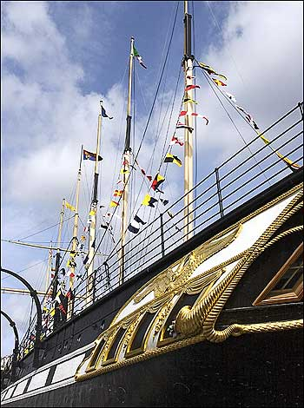
Full details of these events and bookings will be available in future SW newsletters and on the South West regional page.

