What's happening in CIPFA South West – October 2018
Especially for all you members in the Dorset and neighbouring areas!!
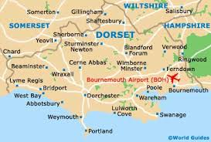Inaugural Dorset/Jurassic Hub Conference
9th November, West Dorset District Council Offices, Dorchester.
CSW are delighted that Carolyn Williamson, Vice President of CIPFA will be able to join us on the day. Carolyn is Deputy Chief Executive at Hampshire County Council, and has masterminded the team at Hants regarding a shared services offering to other councils across the South and London including Oxfordshire CC and the City of Westminster. We are also covering collaboration with the Health sector, audit perspectives from Grant Thornton and investment insights from RP Martin, both sponsors for CSW. Book on our website here

Bristol Distinguished Address Series – BDAS – Autumn Programme now underway
CSW told you in the last newsletter that we are now partnering with the University of the West of England (UWE) at their Frenchay Campus in Bristol with their Bristol Distinguished Address Series CSW think this is a great coup for our Region, and that it offers some excellent CPD for our CIPFA members across our borders with easy access to Bristol! FOR FREE!!!
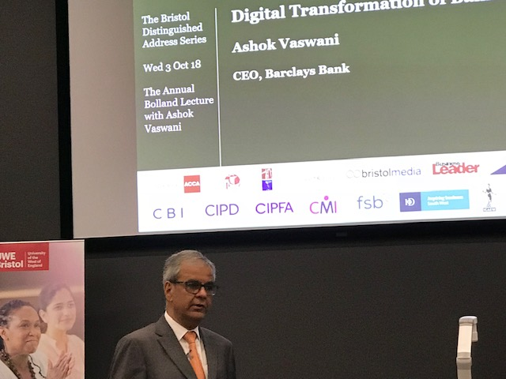
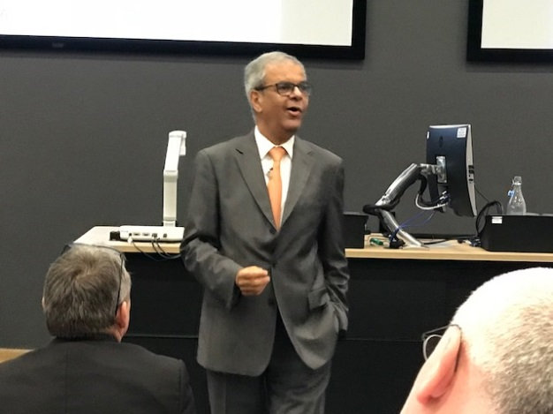
Our President, Christina Earls attended with another member, Stephen Edmonds to the session by Ashok Vaswani, CEO, Barclays. He spoke about “the good, the bad and the ugly” aspects of advancements in technology. For example, how the consumer is able to have instant access to the marketplace through mobile apps, how the automation of some services has taken away jobs, and the increased threat of cyber security attacks. He referred to the 3 key impacts on digital transformation being developments in technology, regulatory changes and changing customer habits. Watch the podcast of his lecture here

Wednesday 17 October 2018: Kevin Ellis, Chair and Senior Partner, PwC UK Registration can be found here.

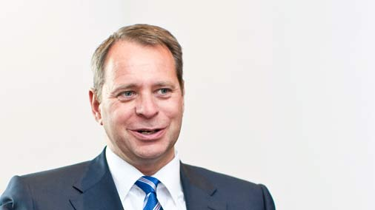

Wednesday 7 November 2018: Ruth Hunt, Chief Executive, Stonewall. Registration can be found here. 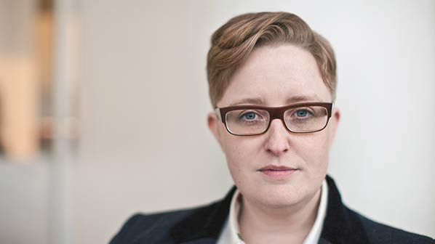

Joint Professions Networking Group – Devon and Somerset (Exeter based)
2nd October – Karime Hassan, Chief Executive, Exeter City Council
Our President, Christina, attended CSW’s first partners meeting of the JPNG, and found out it had been running largely in the Exeter area for the last 9 years. Christina was joined by Joanne Butcher from CSW Regional Council for an excellent evening, listening to Karime explaining his motivation for transforming Exeter, and its importance to the economic wellbeing of Devon. His energetic address on Exeter’s approach to supporting transformational economic growth really demonstrated how much of an impact Exeter has not only on employment, but how embracing technological change is having a real impact on education. He clearly has some great ambitions for the next generation in Exeter!

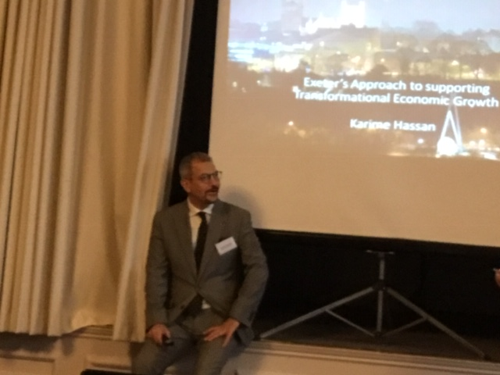

Watch this space for the next event. They are usually held every 3 months or so in the Exeter area.
A Big Welcome to our newest member of CSW Regional Council – Stephen Edmonds!
Following the request that went out in our last newsletter for colleagues in the health sector to join us, Stephen came forward. As it happens he used to work with two of our Regional council members in the past.

Stephen has spent the last four and a half years working for a Commissioning Support Unit in the NHS. Initially in a corporate finance function, he then moved into a more financial consultancy function, offering expert resources, advice and/or guidance to both NHS commissioners and providers as required. Stephen is based in Bristol, but his current role requires working across most of the south of England, as well as delivering projects for NHS England with a national scope. Before his move to the NHS, Stephen spent 11 years at Somerset County Council, starting his career in an entry-level finance role, before progressing in the organisation in both finance and executive-facing and –supporting roles.

Outside of work, Stephen is a keen cricketer and a slightly less keen player of football and softball. Since moving from Somerset to Bristol, Stephen has become involved in the city’s impressive beer scene, and can often be found in pubs, bars and breweries across the city. Christina will be passing to Stephen the responsibility of representing CSW with our links with HFMA

Do we have enough interest for a Retired Members group?
CSW are delighted that a few of you have come forward following our appeal to you to see if there is interest in forming a Retired Members Group in our last newsletter.
Do please still come forward if you have not already. We are looking at the areas where we have interest to set up an initial group soon, so watch this space. We have a considerable amount of experience in our wonderful retired members! Contact us, and share whether you have a view on this.

We are on the look out for more of you to represent all of you,our members and students, whether its geographic, sectoral or category of member. Particularly interested in representatives from students and if you know anyone who is an AAT member that would be happy to engage between us and AAT more – you would be more than welcome! Contact us, and we can let you know more.
Have you a venue so we can Host local events?
Can you host an event in our Region?
Even though we have picked up some promises to host events, we are still looking for great venues near you! We have a range of speakers very happy to come to us on a range of topical events. But we are missing hosts and some help in making it happen. We are currently very keen to commercialisation, digital challenges, collaboration and sharing back office activities, managing change Ethics and ethical behaviour–at whatever position you are. You may like some other topics covered as well, so let us know– especially if you want to cover the topics yourself as a speaker.
Contact Christina via our website

CIPFA South West gets social!
Have you joined us on LinkedIn, Facebook and Twitter yet? Please do, and find a way that we at CSW can keep you up to date with upcoming events, news and discussions that may be of interest to you as a CIPFA member. If you have any ideas on content or suggestions on groups we as a Region should be following then please get in touch.
CIPFA SW Students can also join the student group on Facebook to discuss student related matters such as exams, revisions and events.

CSW needs your help! There are some simple things included below that you can do to support your local Region, including:
- Help us communicate better with you, so if you are on LinkedIn, Facebook or Twitter – join our Groups, share your thoughts and tell us how we can support you more on networking, CPD, even just finding out what CIPFA is doing.
- Consider being our newsletter editor. If you consider yourself a wordsmith and have a few hours to spare why not help us improve this newsletter? Contact us to find out more.
- Help us in developing our area hubs in the south and north of our regions, based loosely around the Plymouth and Bristol/Bath/Swindon areas. Look out for more information in our next newsletter.
Please message us on Facebook or email Joanna Hall if you are interested or if you would like more information and a chat.
Shout out for Student representatives!
Representing the students - over 100 at last count - in our region offers valuable experience to improve your CV and extend your networking across the country. As a student representative you could be involved with a range of activities, including:
- Sharing your views on courses or topics that are covered at events in your region
- Presenting student issues to the CSW council
- Discussing ways of improving the student experience and support
- Organising student CPD and social events
If you're interested in being a student representative and you want to find out more about the role, please message us on Facebook or email Joanna Hall
Save the date! 2018 and 2019 events for your diaries:
University of the West of England BDAS - Kevin Ellis, Chair and Senior Partner, PwC UK
Wednesday 17 October 2018 18.00 – 20.00 Booking open from 19 September using this link here

University of the West of England BDAS - Ruth Hunt, Chief Executive, Stonewall.
Wednesday 7 November 2018: 18.00 – 20.00 Registration will open on the 10th October 2018, at this link here.

Dorset/Jurassic Hub – CSW Inaugural Conference
9th November 09.30 – 16.00, Council Offices, Dorchester. Watch this space, but book the date

Undertaking the 201819 Accounts Closedown

CIPFA Financial Advisory Service – 2 in our area

15 January, 2019 – Bristol Marriot Hotel – to book, go to the CIPFA website here

15 January, 2019 – Exeter Rougemont Hotel – to book, go to the CIPFA website here

CIPFA SW Annual General Meeting and Seminar 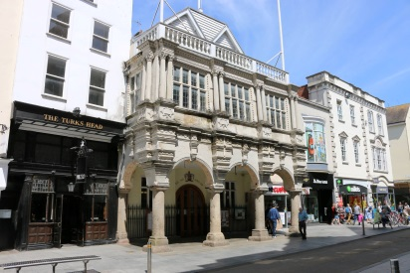
15 March 2019, Exeter Guild Hall 09.30 – 16.00. Booking via CIPFA SW website soon!

Brexit Advisory Commission
April 2019 – Bristol – Watch this space!

CIPFA SW Annual Regional Dinner
24 May 2019, Fleet Air Arm Museum, Yeovilton – Dinner under Concorde 002 Booking via CIPFA SW website. Tickets £50 excl VAT, and discounts for our students and retired members. Book here

