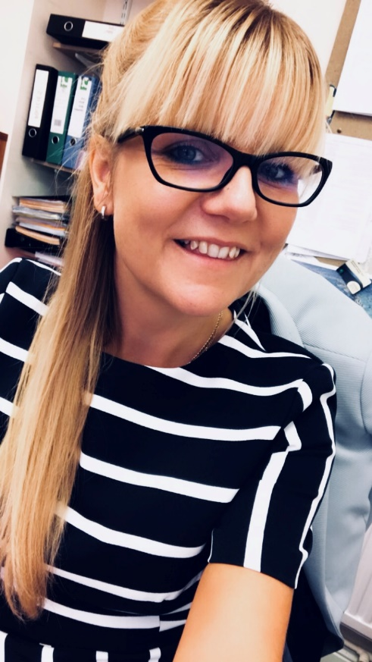
What a busy month it has been already! Both professionally and personally!
As a Town Clerk no two days are the same and this month has been no different. After a nice relaxing holiday with my family in Tenerife with Carl, Charlie (14) and Billy (10) in August, I certainly had to knock it up a gear on my return. Back to school is frantic for any parent but also a relief! Last minute uniform and kit purchases after finding your child has had yet another growth spurt. School drop off, followed by going to the office for that much needed cup of tea. Children who have been on school holidays are very difficult to get up on their first day and it takes nearly a month for them to get back into the routine.
When I get to work there is no routine. I never know what each day is going to bring or what I will be dealing with. My calendar for the week is filled with appointments which offer some certainty, but the spaces in between can be used for sometimes rather random things! Queries about public toilets, allotments, security, hosepipes, community hall, Christmas etc.… Being a Town Clerk means you deal with lots of things and being an expert at many things – or at least knowing someone that is! We are currently inviting companies to tender for our IT Hardware, Software and Technical support. I’m not an IT expert but it’s amazing how quickly you can sound like one, following a few appointments with perspective suppliers.
I’m often visited by Councillors. They come unannounced, but my office door is always open. Anyone who knows me knows I like to talk. It’s good for information gathering. Some of our members are double hatters (sit on both the Town Council and the District Council or County Council); we also have one member who is a triple hatter (sits on all 3 tiers of Council). It’s good to know what’s going on and what impact things may have on the Town Council.
This month was very different as I had time booked out for personal challenge – the Three Peaks Challenge – scaling Ben Nevis, Scafel Pike and Snowdon, for charity in just over 24 hours. This involved walking the equivalent of a marathon up over 10,000 feet. I’ve been training for months but the nerves set in – was I prepared enough. There was a group of 10 of us walking in aid of We Hear You (WHY) who provide free professional counselling to anyone affect by life threatening conditions (in Somerset, Wiltshire and Bath and North East Somerset). WHY does not receive funding from Central Government so they rely on grants, trusts and community fundraising. This was an added motivation. My fundraising efforts benefited from the kindness of those who attended the CIPFA South West Annual Dinner on board SS Great Britain – what a fantastic night that was! The challenge was a test of both mental and physical strength. Every mountain different, Ben Nevis felt like a never-ending ascent, Scafel Pike was plain scary – dark, heavy rain, strong winds, a real test of the mind, Snowdon a bit of a haze but I know I wished my legs were longer, so I didn’t have to haul myself up the big rocks. As with all personal challenges we benefit from the support of others, whether they are also on that same journey or not. The support from everyone was phenomenal. At the time, we all said were most certainly not going to do anything like this again, but almost a week later we are already looking into what to do next. I guess the message here, is you need to believe in yourself and push yourself! As Muhammad Ali said, “if your dreams do not scare you, they are not big enough”. I have big dreams.

