What's happening in CIPFA South West – September 2018
Well, it’s not slowing down just because summer is over! Now its countdown to a busy Autumn here in the West Country.
Bristol Distinguished Address Series – BDAS – Dates for Autumn Programme are now released!
CSW were really happy to tell you in July’s mewletter that we are now partnering with the University of the West of England (UWE) a their Frenchay Campus in Bristol with their Bristol Distinguished Address Series CSW think this is a great coup for our Region, and that it offers some excellent CPD for our CIPFA members across our borders with easy access to Bristol! FOR FREE!!!
BDAS Autumn Programme
Wednesday 3 October 2018 - Annual Bolland Lecture: Ashok Vaswani, CEO, Barclays. The link to register is now open and can be found here: 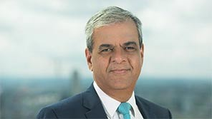

Wednesday 17 October 2018: Kevin Ellis, Chair and Senior Partner, PwC UK Registration will open on the 19 September 2018, at this link here.
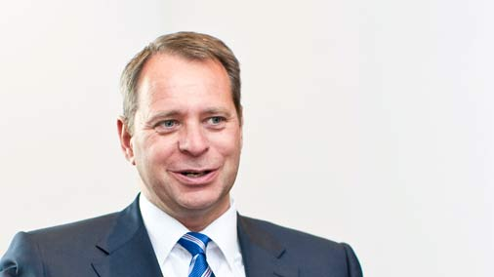

Wednesday 7 November 2018: Ruth Hunt, Chief Executive, Stonewall. Registration will open on the 10th October 2018, at this link here. 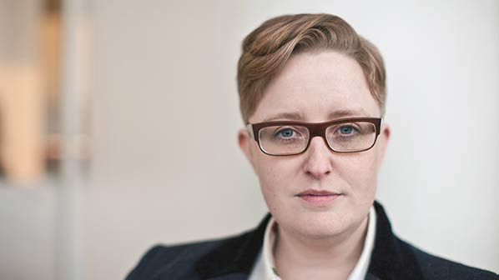
And CIPFA South West is pleased to announce another New Partnership with the Joint Professions Network in the South West
The JPN has apparently been running in the Exeter area for some 9 years, led by the Devon and Somerset Law Society, but includes ACCA SW, ICAEW SW and CIMA plus many other SW Professional Societies. And now us!!!!
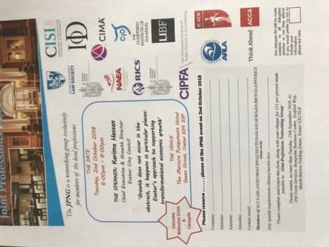
Costing £15 for canapes and drinks, the next event is:
October 2nd, 6pm – 8pm with THE SPEAKER: Karime Hassan, Chief Executive & Growth Director of Exeter City Council.
Venue: The Mercure Rougemont Hotel, Queen Street, Exeter EX4 3SP
On the subject of:
‘Growth does not occur in the abstract, it happens in particular places:
Exeter’s approach to supporting transformational economic growth’

There is a form to complete with your payment, Contact us via this link so we can send you the form.

And if that is not enough, CIPFA South West Announces the formation of a DORSET/JURASSIC Hub.
Inaugural conference 9th November, Dorchester
You may have seen that there is a lot going in in the local government space in Dorset! And CSW are very proud of the Financial Services – Treasury Team, Dorset Council Partnership, which is one internal staffing organisation serving North Dorset and West Dorset District Councils and Weymouth &Portland Borough Council. The team won the Innovation in Treasury and Asset Management award for 2018.
And that’s not forgetting that they were also shortlisted for the 3 Council Finance Systems with automated cost sharing in the Digital Finance Project of the Year Category and for Finance Team of the Year, local services.
Watch our social media for more details, but save the date and venue!

Return of the Brexit Advisory Commission for Public Services to Bristol. April 19
Some of you may recall that CSW supported CIPFA’s Brexit Commission as it came to Bristol in February, earlier this year. CSW are working with them again to return, with a view to considering progress – or not! And updates on the position the South West faces following the work done by the government in the meantime. So, watch this space!!!

A huge shout out for our VP Amanda Card!
CSW just wants to say a huge “well done” to our Vice President, Amanda, who recently completed the Three Peaks Challenge. Amanda is Town Clerk for Yeovil, and was with a team raising money for a local Yeovil charity We Hear You. She has raised a whopping amount - almost £1,700! Well done!!!!
Dismiss
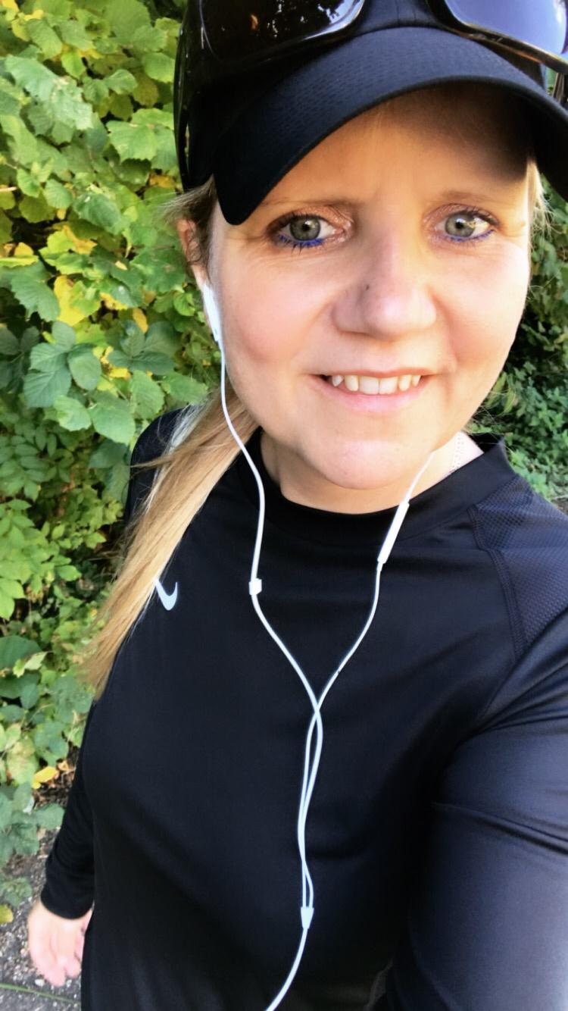

We have so many dedicated people amongst us here in the South West who volunteer for many good causes and raise money in many charity events across our Region. Why don’t you let us know your story?

Do we have enough interest for a Retired Members group?
We have a number of members who are no longer in active full time employment, but who are interested in what’s happening with CIPFA and would like to share their wide experiences for sharing ideas and stories. CSW were also very pleased to meet at the Torbay CSW AGM and the CIPFA AGM in Bournemouth some of them who still retain a membership and interest in what’s happening. Hello, Aubrey, who we met at Torquay, and David, who we met in Bournemouth! We have a considerable amount of experience in our wonderful retired members! Some of the Regional Council members are now getting very interested in whether there is sufficient call to creating a “Retired” members group. Contact us, and share whether you have a view on this.

We are on the look out for more of you to represent all of you,our members and students, whether its geographicl, sectoral or category of member. Particularly interested in representatives from students and health, and if you know anyone who is an AAT member that would be happy to engage between us and AAT more – you would be more than welcome! Contact us, and we can let you know more.
Have you a venue so we can Host local events?
Can you host an event in our Region?
Even though we have picked up some promises to host events, we are still looking for great venues near you! We have a range of speakers very happy to come to us on a range of topical events. But we are missing hosts and some help in making it happen. We are currently very keen to commercialisation, digital challenges, collaboration and sharing back office activities, managing change Ethics and ethical behaviour–at whatever position you are. You may like some other topics covered as well, so let us know– especially if you want to cover the topics yourself as a speaker.
Contact Christina via our website

CIPFA South West gets social!
Have you joined us on LinkedIn, Facebook and Twitter yet? Please do, and find a way that we at CSW can keep you up to date with upcoming events, news and discussions that may be of interest to you as a CIPFA member. If you have any ideas on content or suggestions on groups we as a Region should be following then please get in touch.
CIPFA SW Students can also join the student group on Facebook to discuss student related matters such as exams, revisions and events.
CSW needs your help! There are some simple things included below that you can do to support your local Region, including:
- Help us communicate better with you, so if you are on LinkedIn, Facebook or Twitter – join our Groups, share your thoughts and tell us how we can support you more on networking, CPD, even just finding out what CIPFA is doing.
- Consider being our newsletter editor. If you consider yourself a wordsmith and have a few hours to spare why not help us improve this newsletter? Contact us to find out more.
- Help us in developing our area hubs in the south and north of our regions, based loosely around the Plymouth and Bristol/Bath/Swindon areas. Look out for more information in our next newsletter.
Please message us on Facebook or email Joanna Hall if you are interested or if you would like more information and a chat.
Working with HMFA colleagues
Christina, our President attended the HFMA South West Regional meeting, as a member on 13 September. CSW is now looking for a proactive health sector colleague who will join our Region to represent this sector and take on the link with HFMA. HFMA SW has their South West Conference in 20-21 September, and it would be great to have contact with anyone who is attending CSW is looking to sponsor CIPFA students employed in Health to attend future conferences.
Shout out for Student representatives!
Representing the students - over 100 at last count - in our region offers valuable experience to improve your CV and extend your networking across the country. As a student representative you could be involved with a range of activities, including:
- Sharing your views on courses or topics that are covered at events in your region
- Presenting student issues to the CSW council
- Discussing ways of improving the student experience and support
- Organising student CPD and social events
If you're interested in being a student representative and you want to find out more about the role, please message us on Facebook or email Joanna Hall
Save the date! 2018 and 2019 events for your diaries:
Joint Profession’ Networking Group - Karime Hassan, Chief Executive & Growth Director for Exeter City Council.
Tuesday 2nd October 2018 - 18.00 – 20.00 Mercure Rougemont Hotel, Queen Street, Exeter EX4 3SP Cost £15.
To get the form to complete to attend contact us at our email cipfasw@cipfa.org

University of the West of England BDAS - Ashok Vaswani, CEO, Barclays.
Wednesday 3 October 2018 - 18.00 – 20.00 Book via the link here:

University of the West of England BDAS - Kevin Ellis, Chair and Senior Partner, PwC UK
Wednesday 17 October 2018 18.00 – 20.00 Booking open from 19 September using this link here

University of the West of England BDAS - Ruth Hunt, Chief Executive, Stonewall.
Wednesday 7 November 2018: 18.00 – 20.00 Registration will open on the 10th October 2018, at this link here.

Dorset/Jurassic Hub – CSW Inaugural Conference
9th November 09.30 – 16.00, Council Offices, Dorchester. Watch this space, but book the date

CIPFA SW Annual General Meeting and Seminar
15 March 2019, Exeter Guild Hall 09.30 – 16.00.book the date!

Brexit Advisory Commission
April 2019 – Bristol – Watch this space!

CIPFA SW Annual Regional Dinner
24 May 2019, Fleet Air Arm Museum, Yeovilton – Dinner under Concorde 002 Book the date!

